## horizontal line

**TechDocs Documentation**

Version 1.0

**─**



Great Learning

Team TechDocs

2023

# 

# **Overview**

TechDocs is a great on-line LaTeX editing tool that allows you to create LaTeX documents directly in your web browser. This document explains how to create a new project in TechDocs, either starting from scratch, uploading your own files or using one of the many templates available.

# **Getting Started**

TechDocs is available as an on-premises or a cloud-based offering. This section explains the product and some concepts related to TechDoc.

## Orientation

This document explains how to create a new project in TechDocs, either starting from scratch, uploading your own files or by using one of the many templates available.

## User goals and features

The following table lists the different users of Techdocs and how these users can achieve their goals by using TechDocs:

|  |  |  |
| --- | --- | --- |
| Role | Goal | How Techdocs helps the user achieve this goal |
| Authors | Write, edit, manage, and publish articles | Provides tools to write, edit, collaborate, submit, and manage articles through to publication |
| Groups | Write, edit, manage, and publish articles | Provides simple functionality to share technical docs between peers |
| Teachers | Write, edit, manage, and publish articles | Provides tools to write, edit, collaborate, submit, and manage articles through to publication. |
| Publishers | Write, edit, manage, and publish articles | Provides tools to write, edit, collaborate, submit, and manage articles through to publication. |
| Students and Researchers | Write, edit, manage, and publish research project documents | TechDocs professional features that provide streamlined branded enrollment and a resource portal with featured templates, training, and administrative analytics and metrics to help students, researchers, faculty and staff in universities collaborate |

## Pricing and licensing overview

The following types of subscriptions are available:

* TechDocs Standard
* TechDocs Premium

# **Navigating Techdocs**

Techdocs has a graphical user interface (UI) to help you access the different menus and options.

Tech docs UI includes the following tabs:

* Register — Allows users to register or create an account in TechDocs.
* Login — Allows registered users to log in by using their login credentials.
* Home — Allows users to return to the Home page.
* Features — Depending on your goal as described in the User goals section, you can select one of the following features:
  + For Writing
  + For Students
  + For Teachers
  + For Universities
* Subscription — Allows users to make select a subscription plan and make payments.
* Help — Allows users to access the TechDocs online help documentation.

## Accessing and navigating TechDocs

To start using TechDocs go to the [TechDocs](http://techdocs.previewbox.in/) site.

If you don’t already have an account, you need to register yourself to create an account.

You can register by using your Google account or with your Email address.

If you already have an account, click Login in the upper right corner, then type in your email and password and click **Login**.

After you are logged in, you should see the TechDocs Dashboard page.

# **Using Techdocs**

## Registering with TechDocs

If you don’t already have an account, you need to register yourself to create an account.

You can register by using your Google account or your Email address.

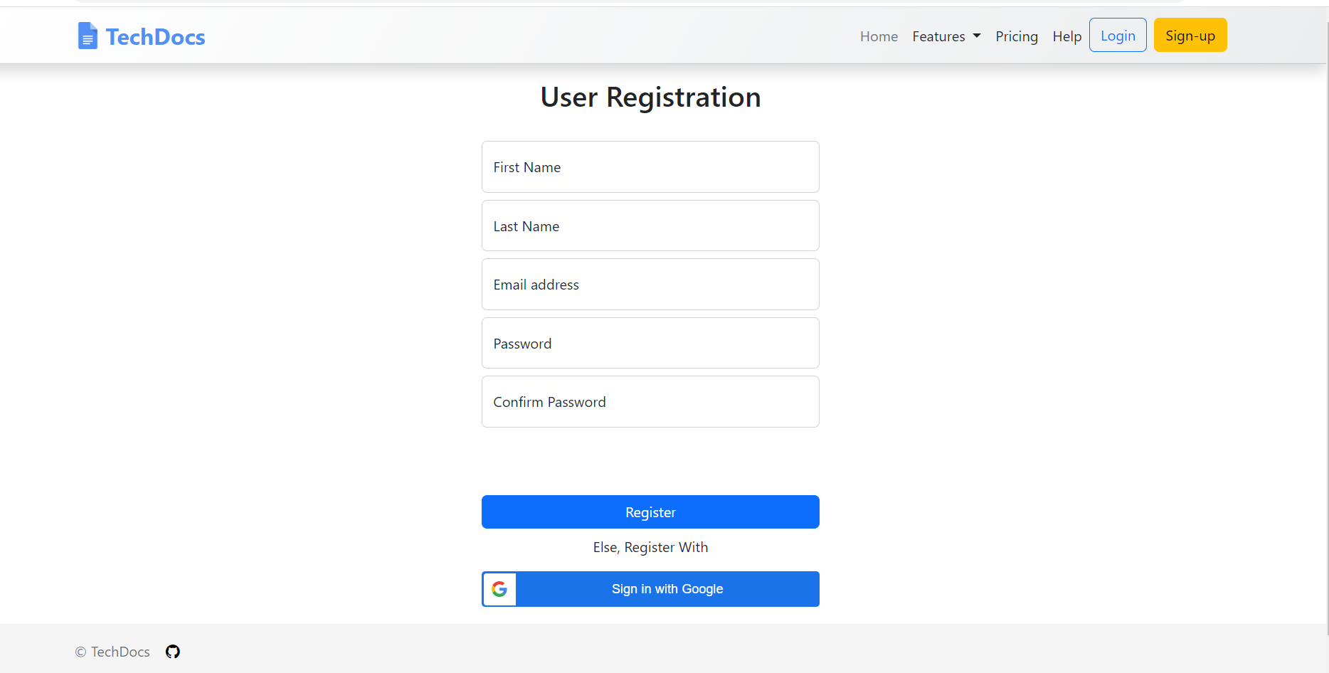

A welcome message is displayed and you are prompted to create your first project.

On the TechDocs Dashboard, click **New Document** to create a new project.

Choose from one of the following project templates:

Blank template

Resume template

## Forgot Password

As users of various sites, we sometimes forget our passwords. We have got you covered. You can simply click on the Forgot Password link on the Login page and submit your email id. An auto-generated email containing a password reset link is sent to your email id. Using that you can reset your password seamlessly.

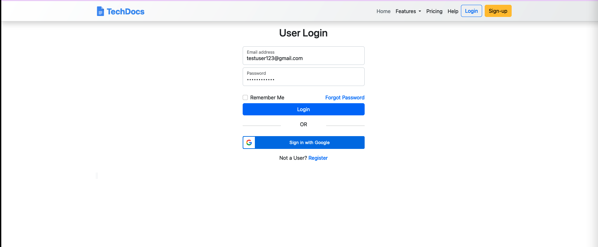

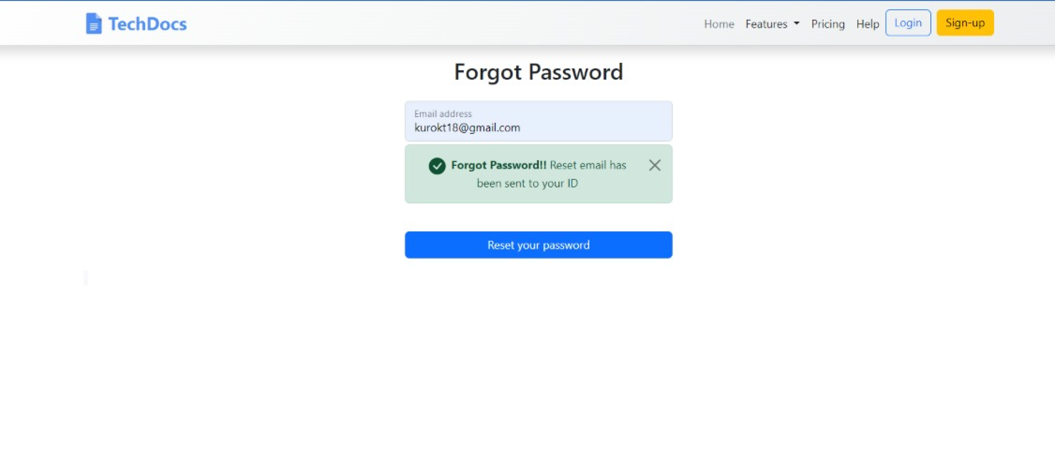

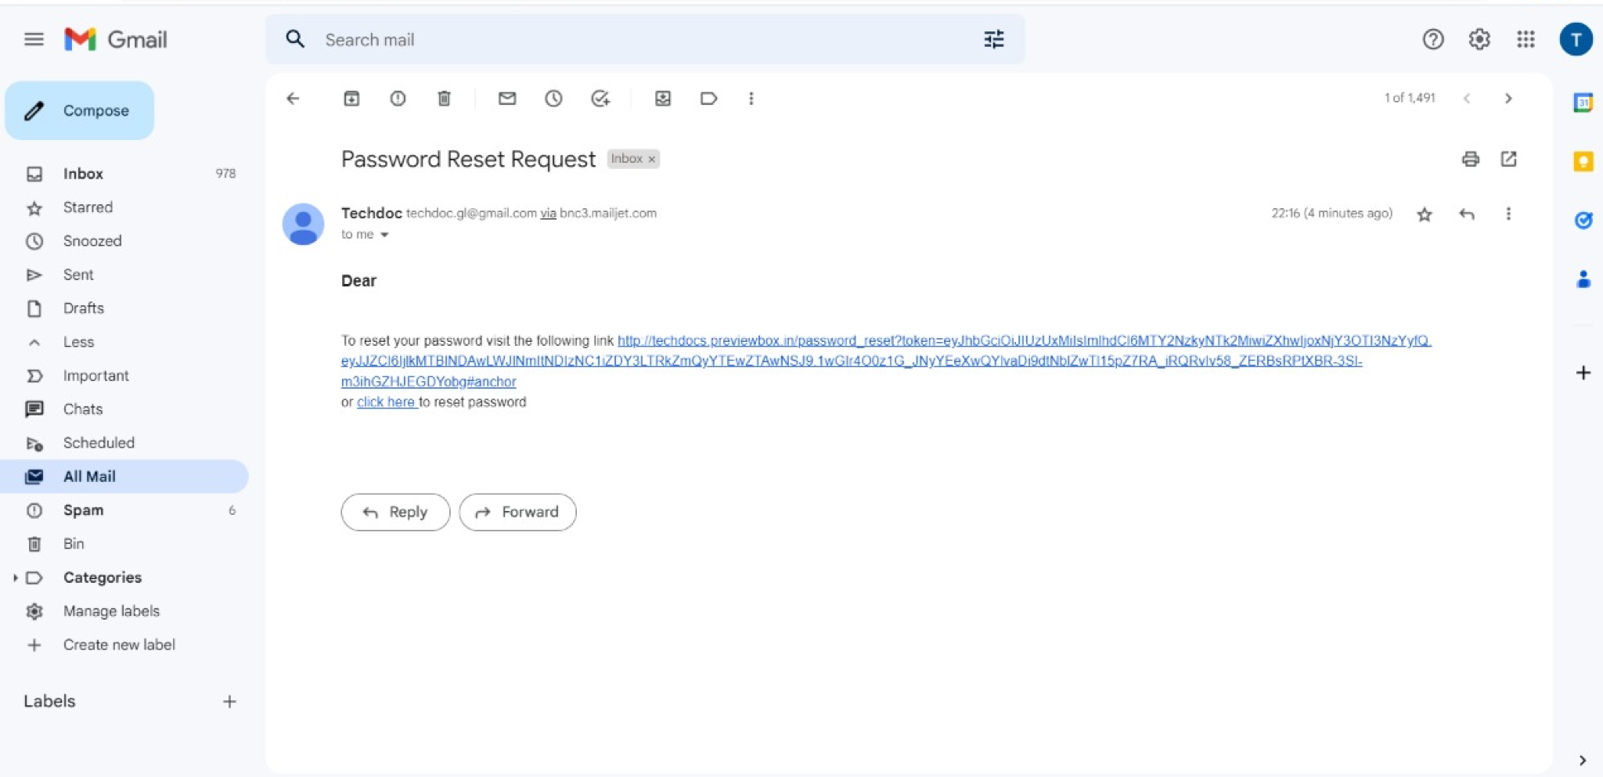

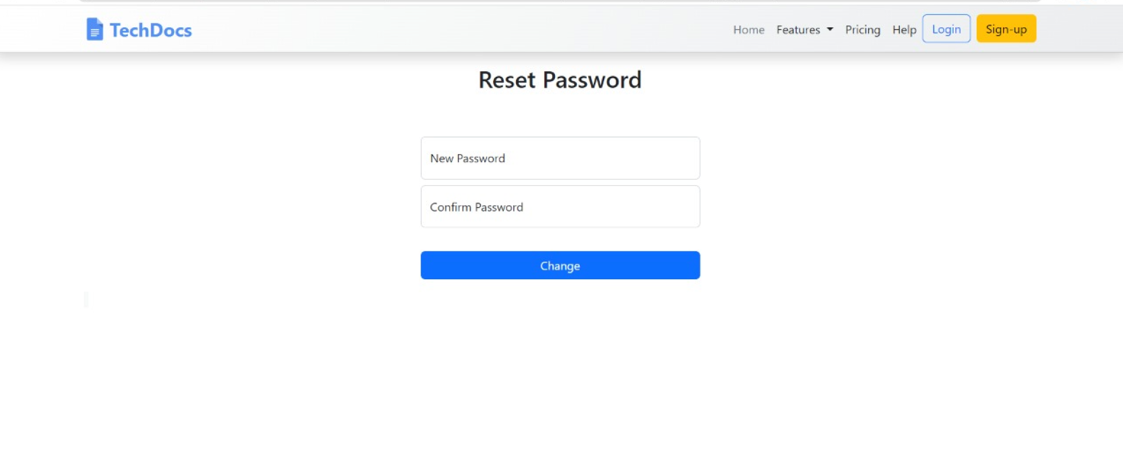

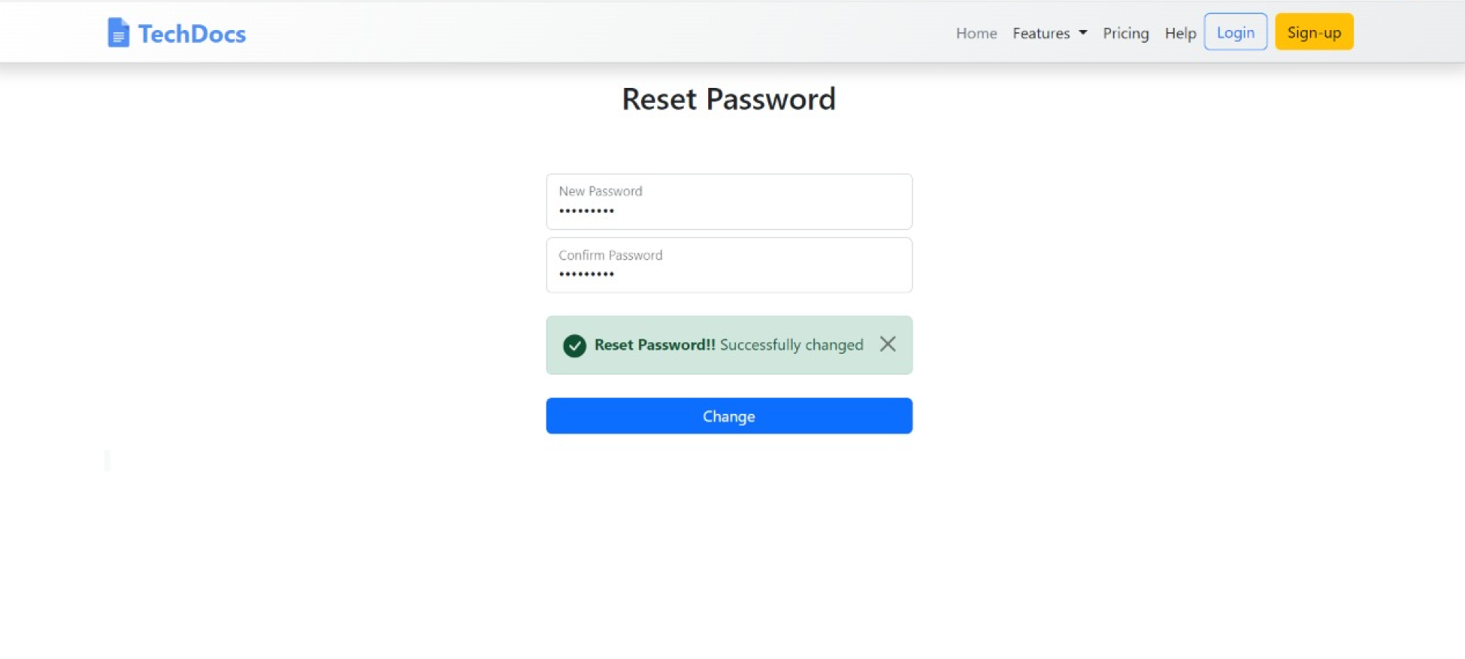

## Creating a new document in TechDocs

1. Log in to TechDocs by using your login credentials.
2. On the Dashboard page, click **New Document** > **Blank Project**.
3. Enter a name for your project and click on the “tick mark” button to save the file.

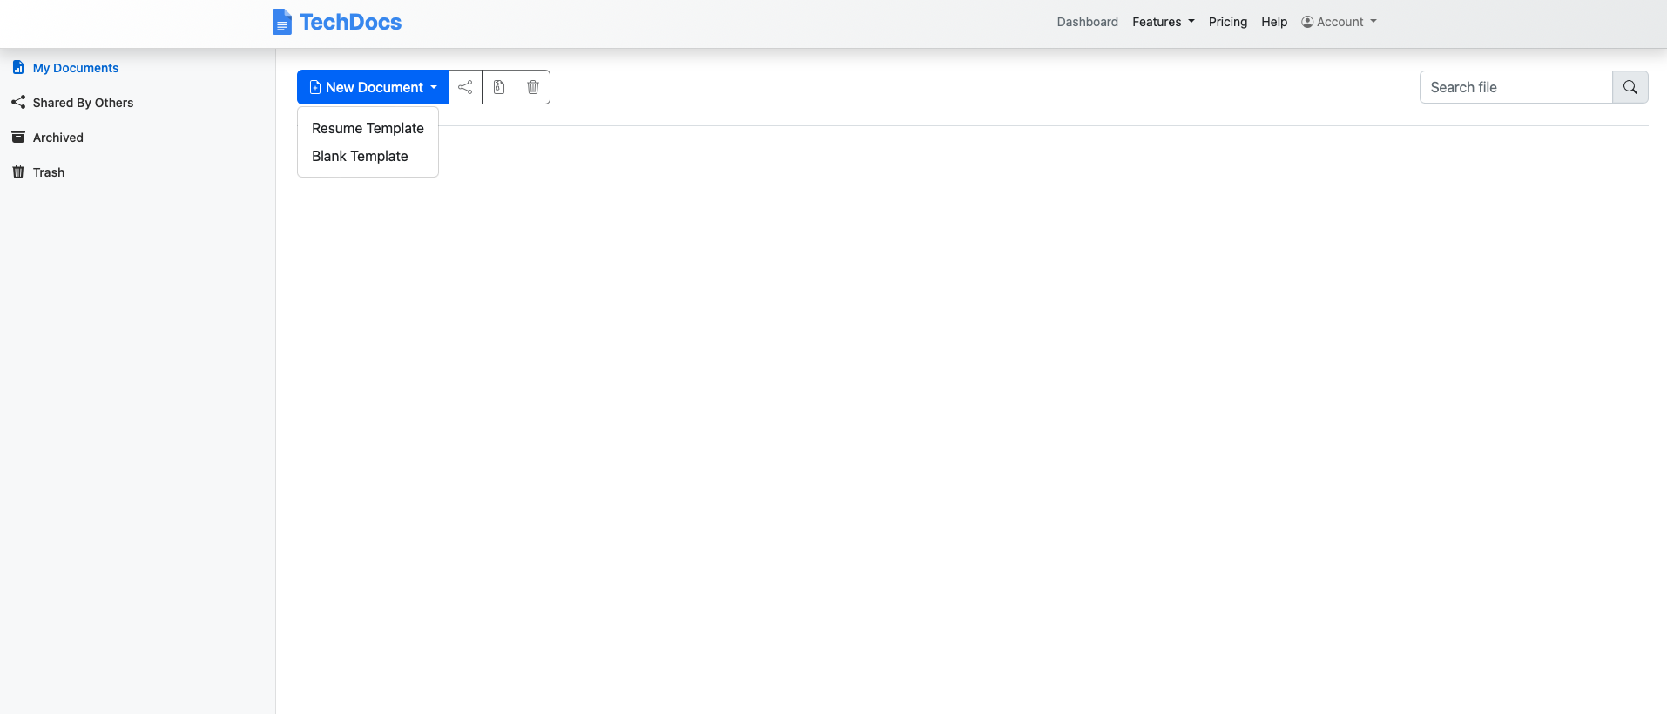

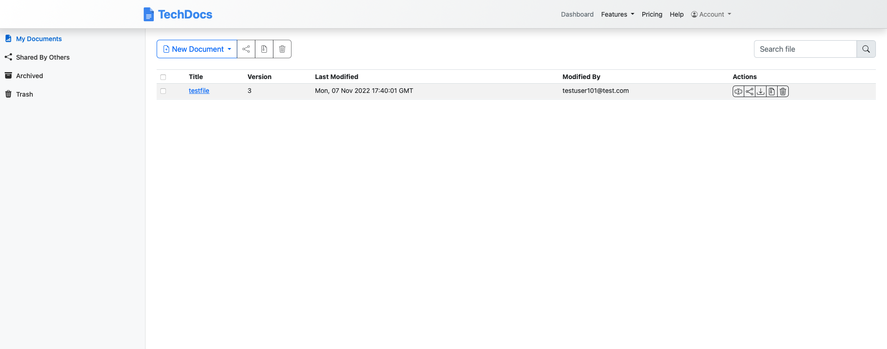

## Editing a document in TechDocs

You can edit your LaTeX documents in TechDocs Dashboard by clicking on the file. Once you have made the required changes, you can get back to doing other work as the Auto-Save feature takes care of saving the document as you keep editing it making it a hassle-free save.

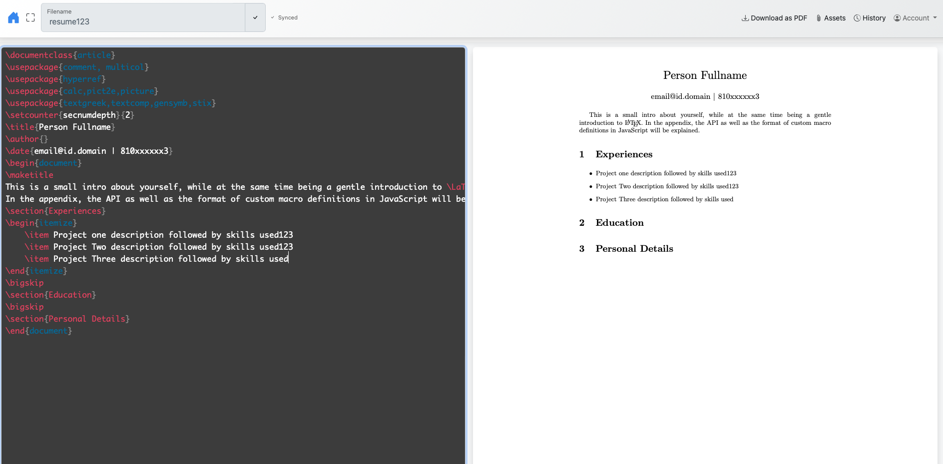

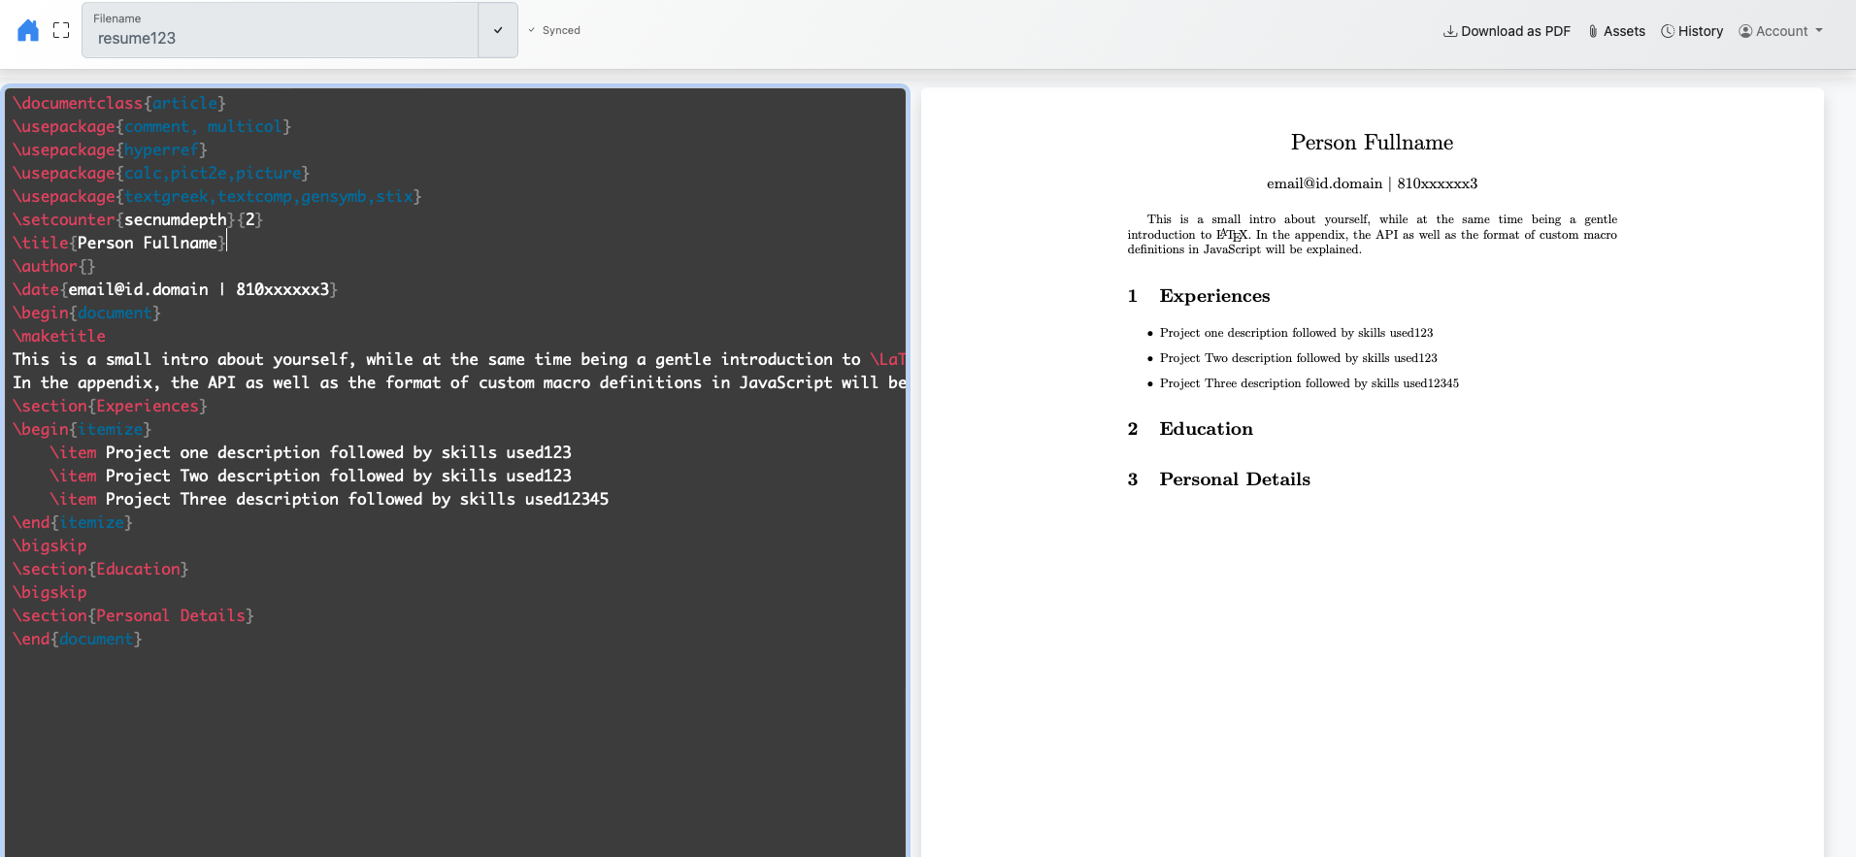

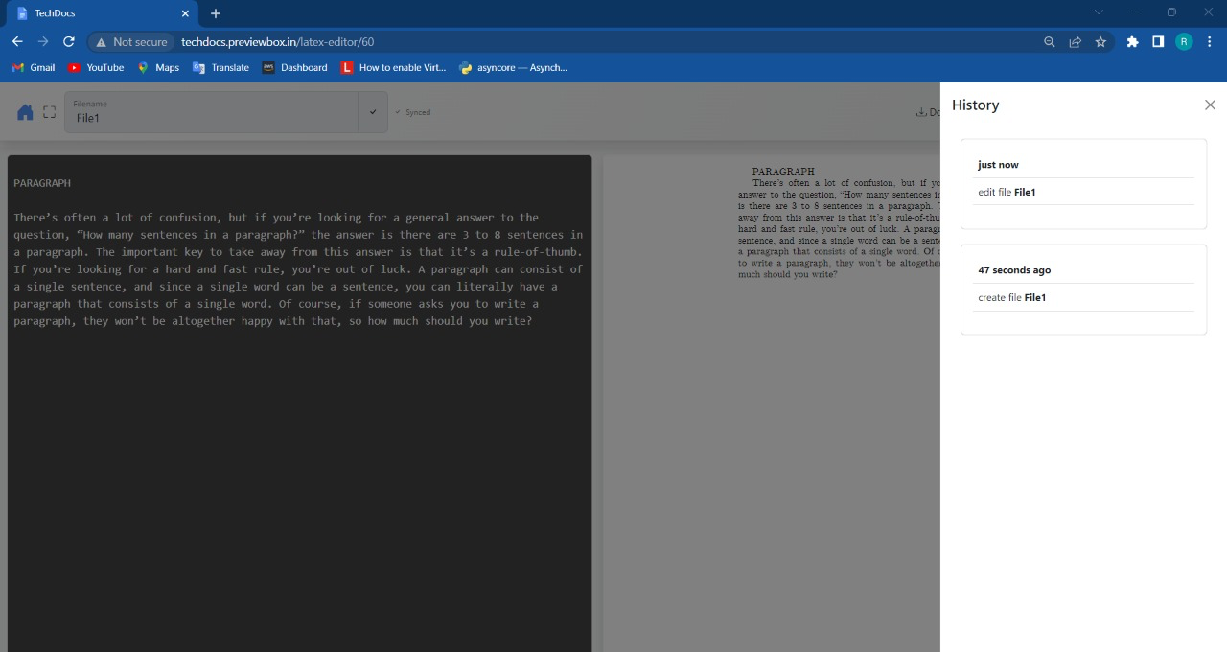

## Sharing a document in TechDocs

You can share your LaTeX documents with your peers in TechDocs Dashboard by clicking on the Action buttons against a file. Update the user’s email id with whom you would like to share your document and select the type of permissions you would like to provide. Click on Confirm. The file is visible to the other user in the Shared by Others section on the Dashboard.

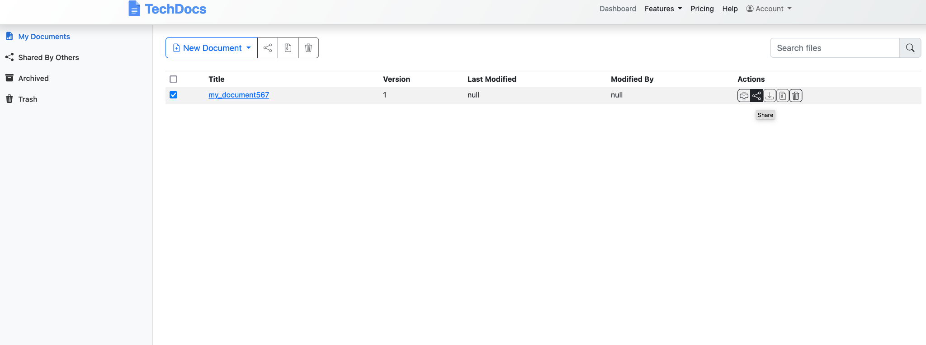

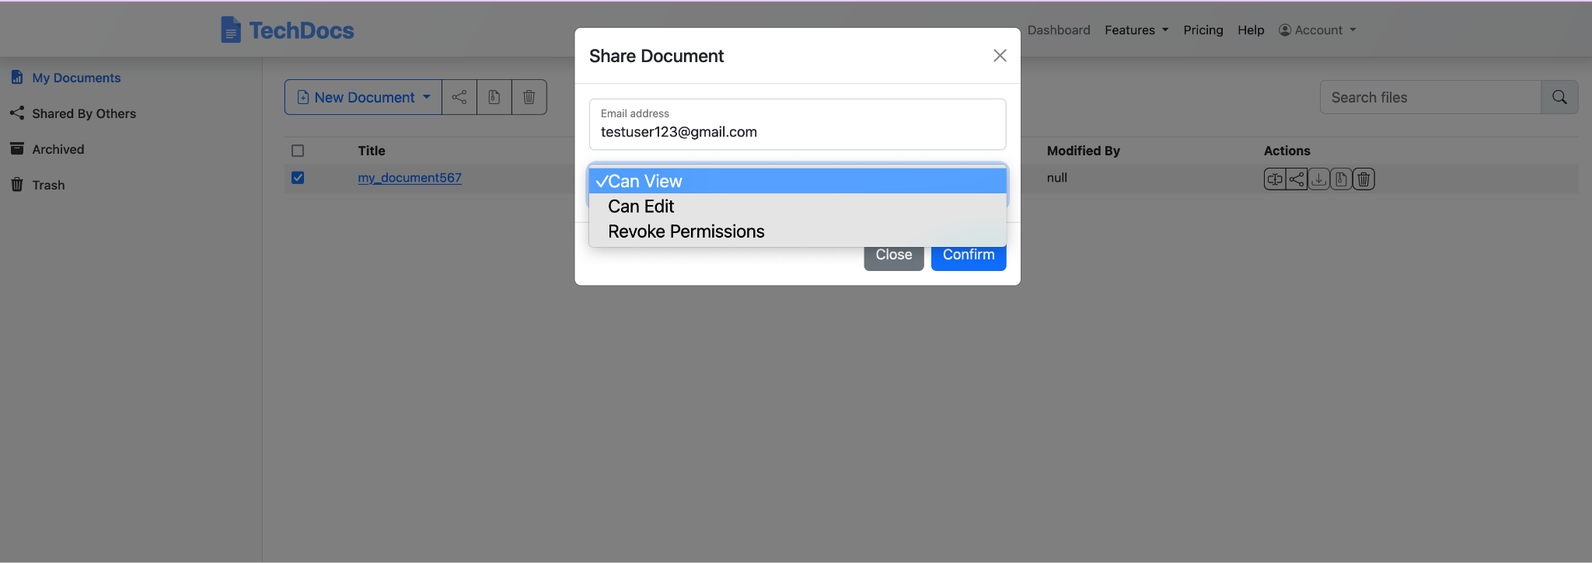

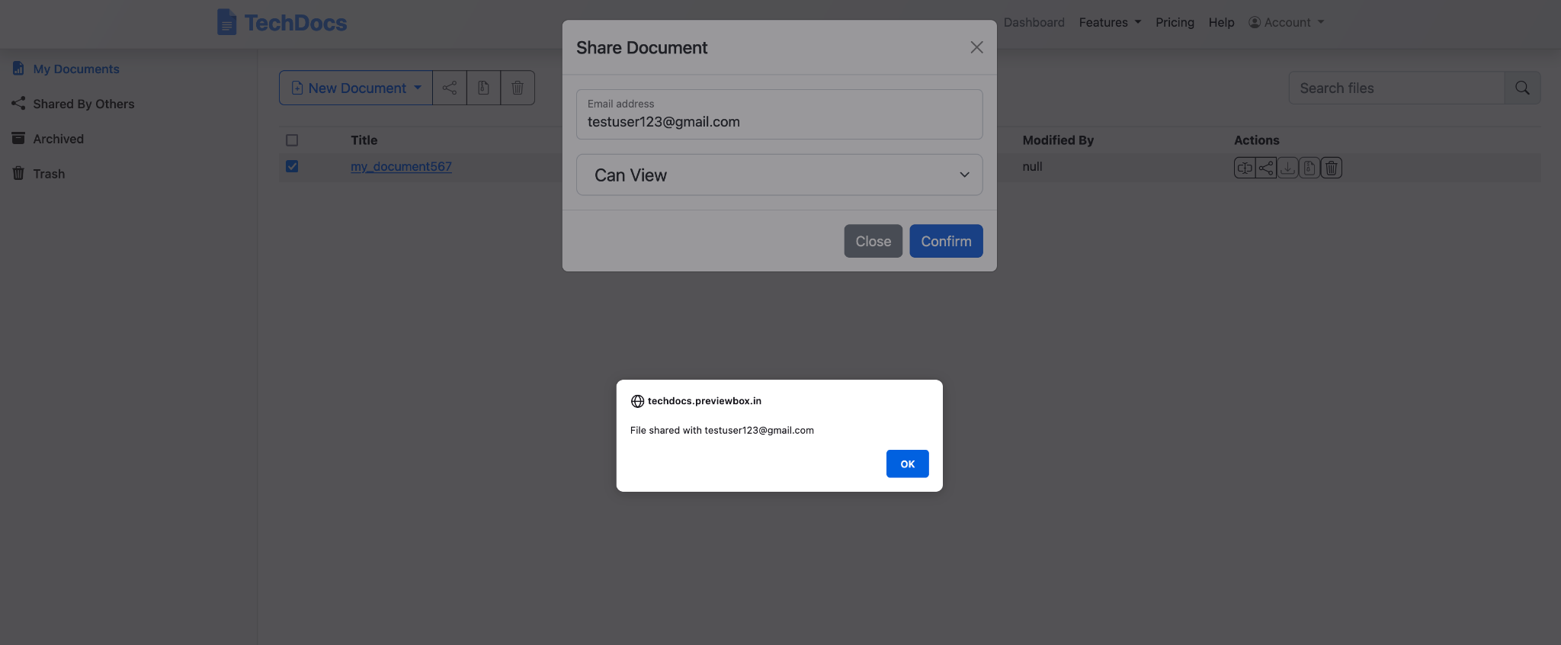

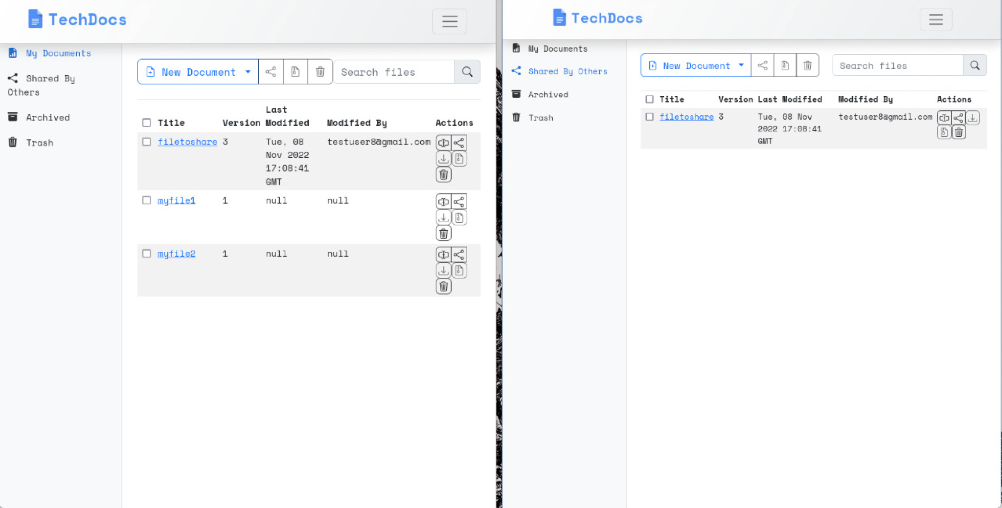

## Exporting your work from TechDocs

You can export TechDoc projects as a PDF file.

### To download the PDF file

1. Open the file from the Dashboard.
2. On the top right corner, click **Download as PDF** icon.

### To download a LaTex file

1. Go to Dashboard
2. Select the file you wish to download.
3. Click on the Download button in the Actions section.

## Deleting a File

To delete a file, you must select it by clicking on the checkbox as shown below and then hit the Delete icon on the right across the file. The file is moved to Trash from where you can either delete it permanently or restore it.

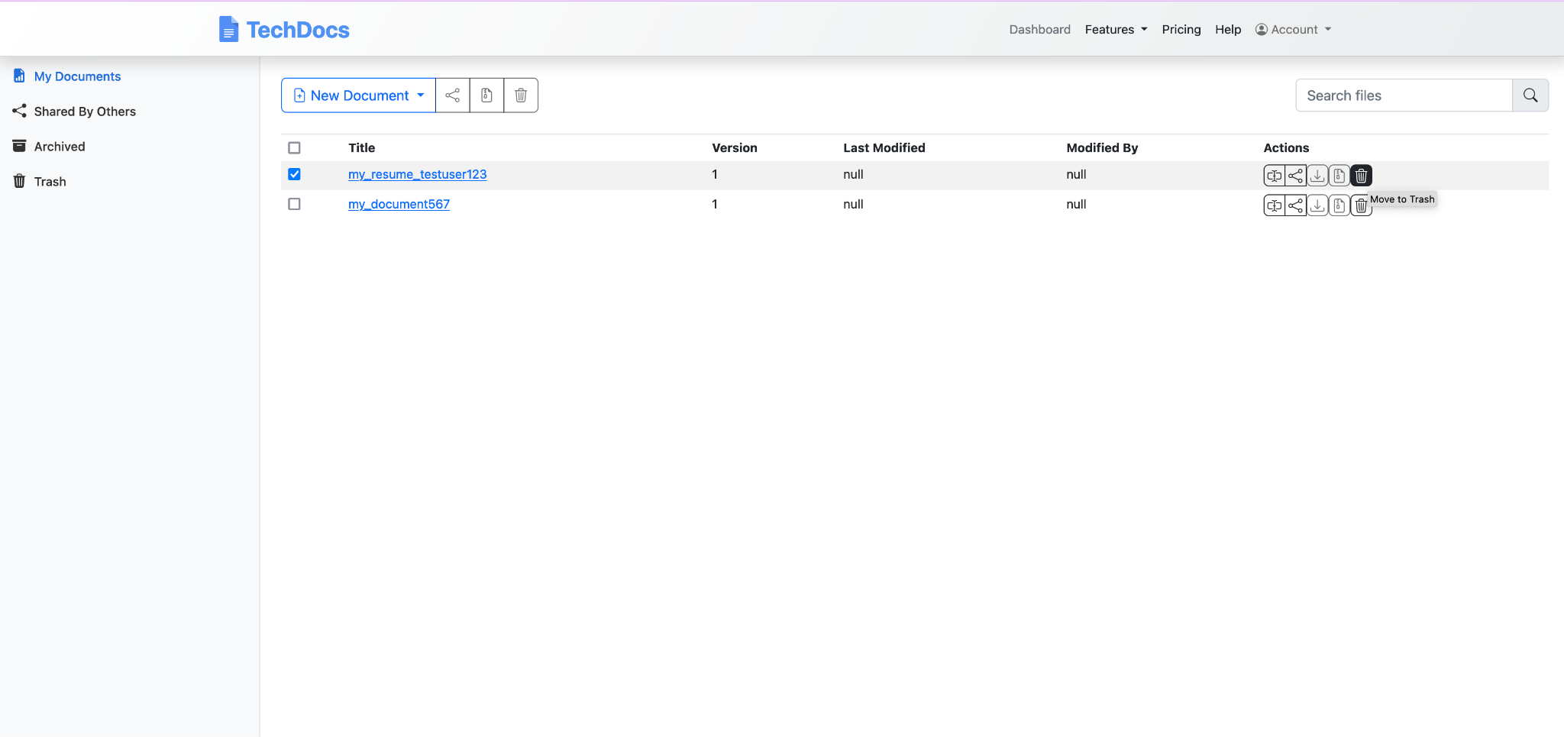

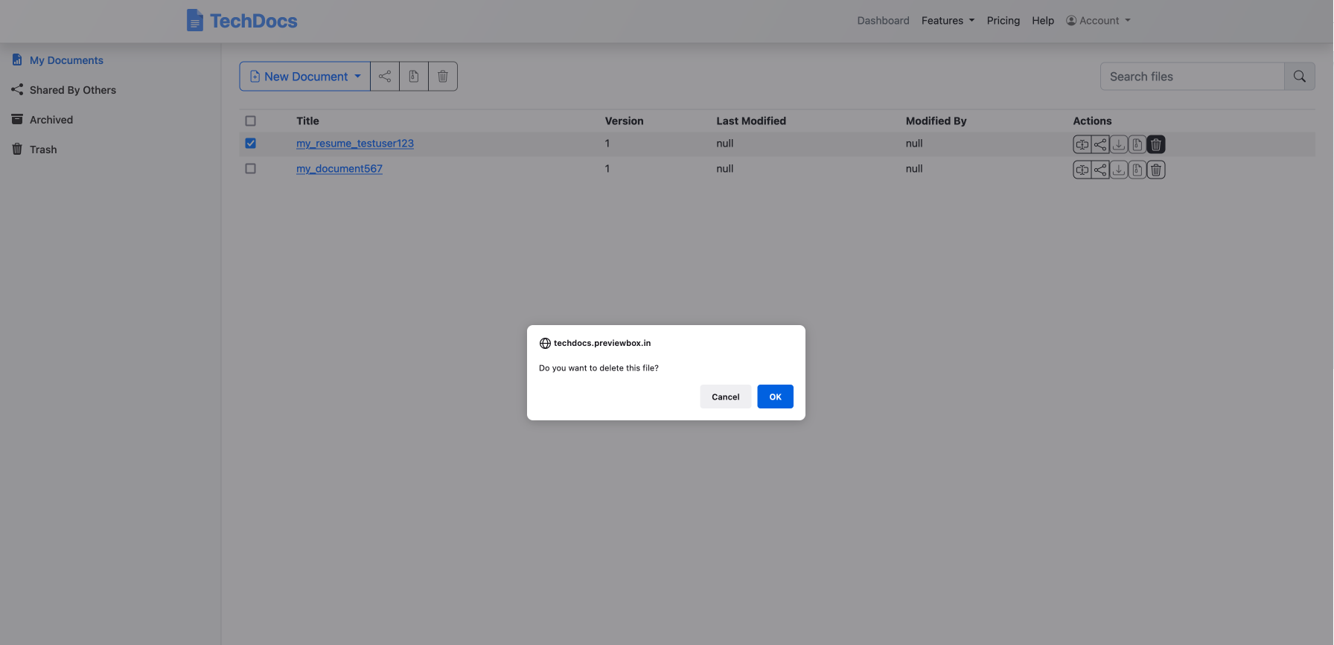

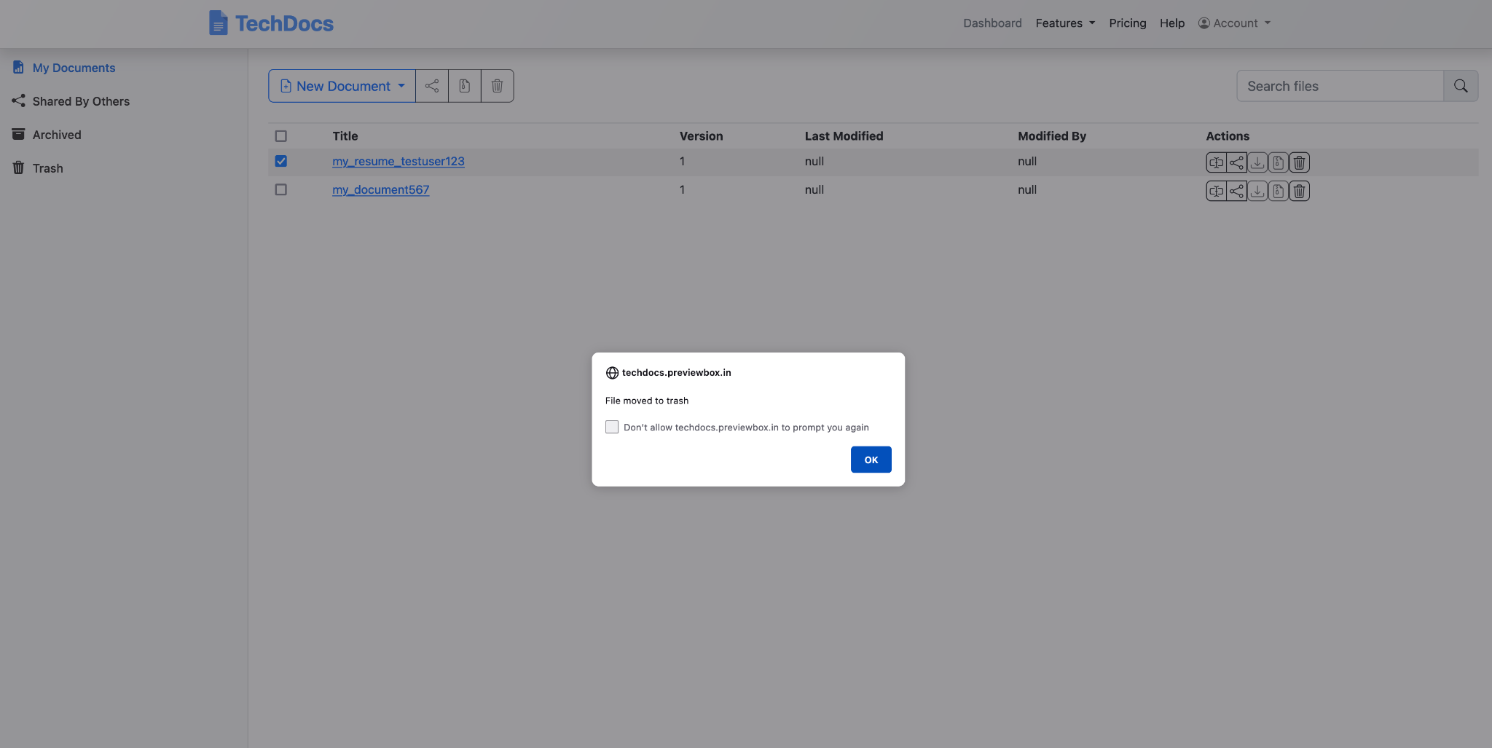

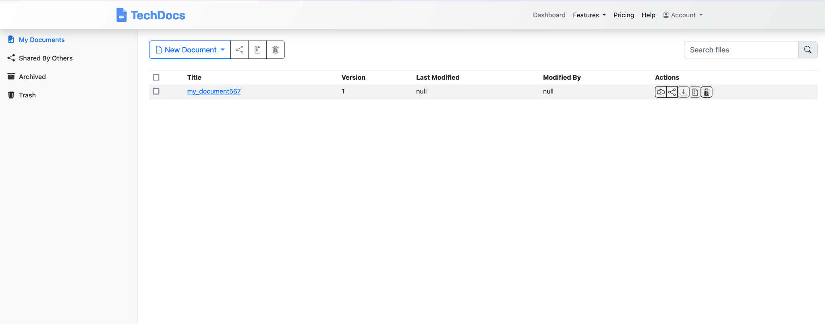

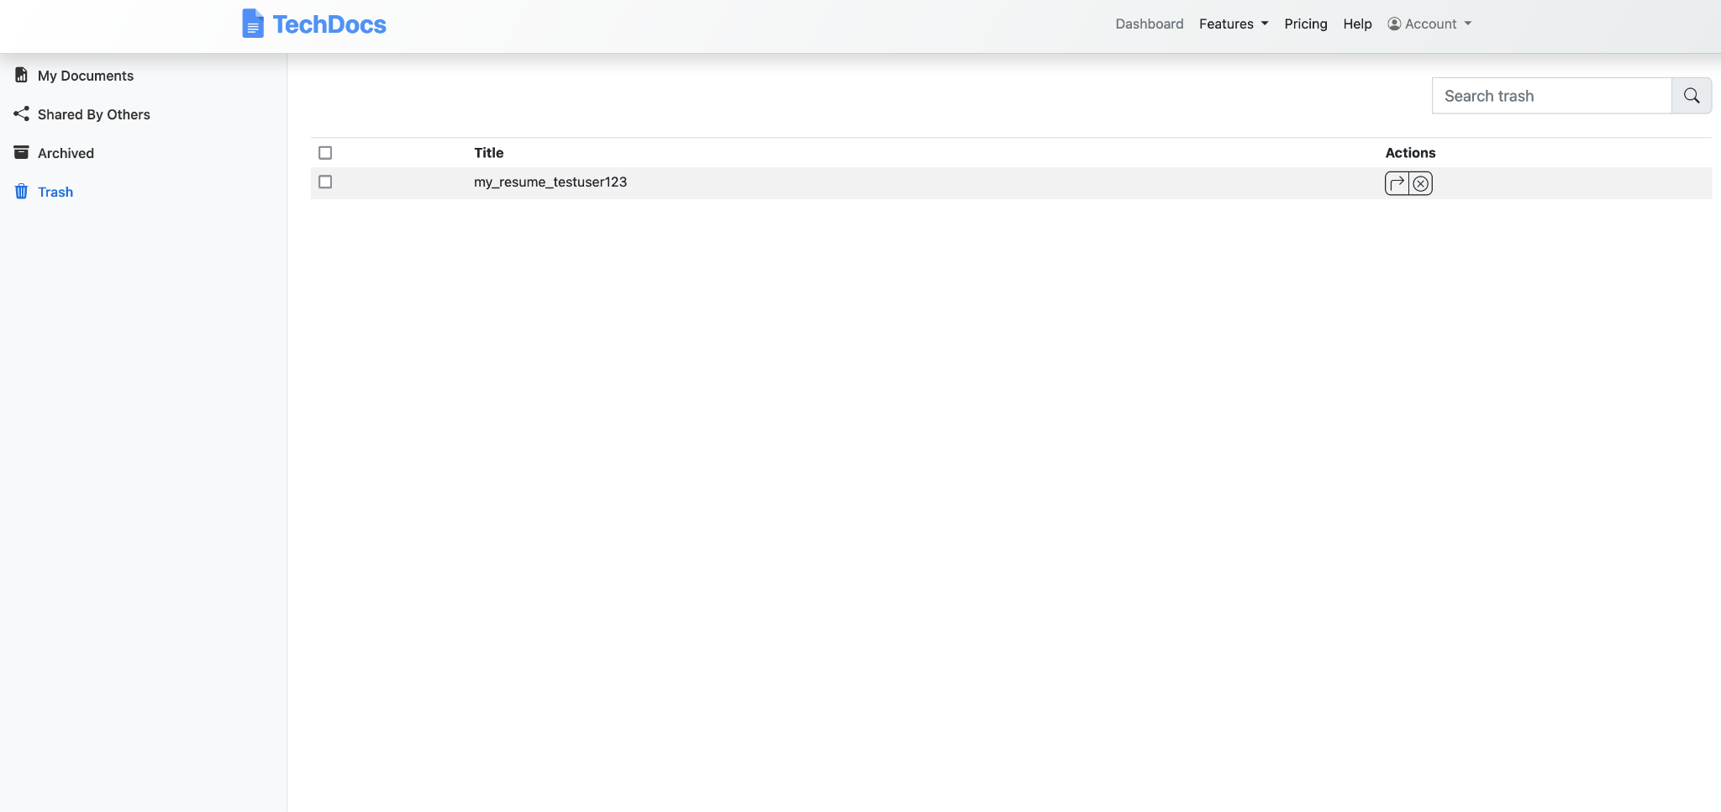

If you don’t have sufficient privileges, then you cannot delete the file as shown below.

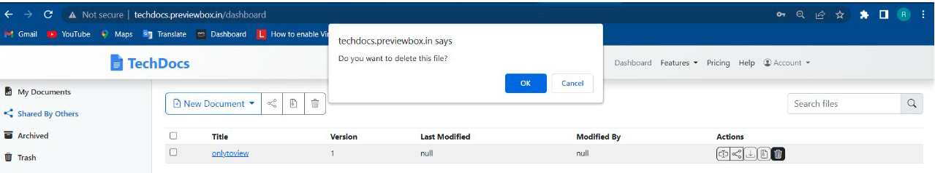

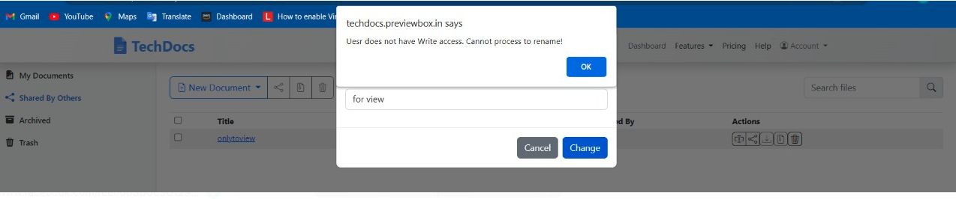

## Searching for files

Searching for files is pretty simple and effective. You can type a character or a string in the Search box and it starts listing all the files in your Dashboard available for you.

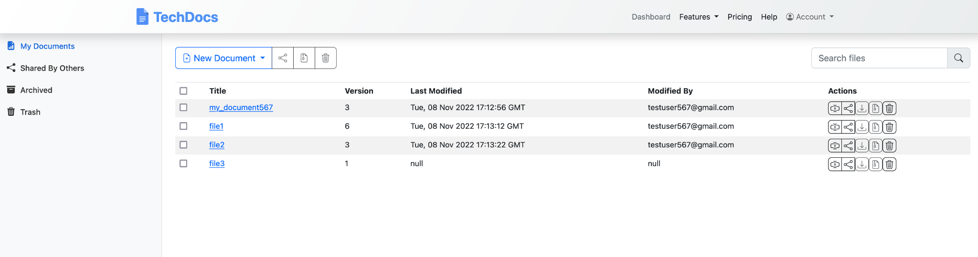

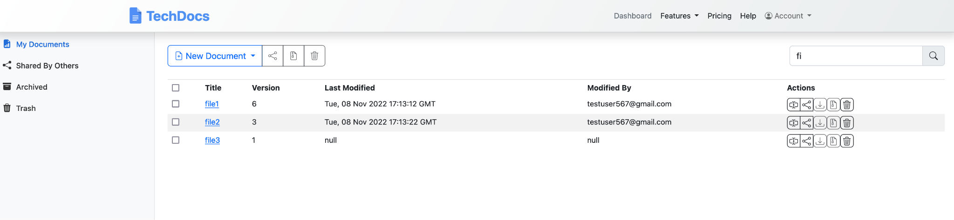

# **Backend Services**

## User registration

This service takes the user’s email id, first name, last name for creating their account and allows the user to set their password. When the user is successfully registered, it returns a confirmation message “You are registered and can now login”.

In case a user is already registered or the service is unable to complete the registration then appropriate responses are sent to the user.

## User authentication

### **Sign in service:**

This service first authenticates the user. After a successful authentication, a non-expiring JWT token is generated which encodes the email id and the IsAdmin field, which by default is set to false. This token is returned along with the first name and last name fields.

### **Sign out service:**

The service updates the last active date in the user profile, and sends out a JWT token as a success response.

## User profile management

### **Get profile:**

After validating the user’s authorization token, the service returns the user details such as first name, last name, street address, state, country, occupation, purpose of use, sign up date and last active date from the database.

### **Update profile:**

After validating the user’s authorization token, the service allows the user to update their profile details such as first name, last name, street address, state, country, occupation, purpose of use.

### **Delete profile:**

This service accepts the password from the user and after validating it, the user is allowed to permanently delete all versions of the selected file provided the user has delete permissions.

## Change password

This service validates the user’s current password and allows users to change their password after the validation is successful.

## Forgot password

This service sends a password reset link to the provided email id, provided the email id is found in the database.

## File manager

### **Create a file:**

This service allows users to create a new file and assigns appropriate permissions to the user as the file owner. This file can either be empty or already have data in it.

### **Modify a file:**

This service checks if the user has ‘write’ permission assigned to them and allows the user to update the contents of a file. It saves the changes made in the file in a new version of the file.

### **View a file:**

This service checks if the user has ‘read’ permission assigned to them and then allows them to view the contents of the latest version of the file.

### **Rename a file:**

This service allows the user to rename the existing files if they have the write permission.

### **Move file to trash:**

This service checks if the user has ‘delete’ permission assigned to them and then allows a user to move all versions of a file to trash.

### **Retrieve file from trash:**

This service allows a user to retrieve all versions of a file from trash.

### **Shared by others:**

This service allows you to view and edit the files shared by others with you.

### **Files in trash:**

This service allows the user to see all the files they have moved to trash.

### **Delete file permanently:**

This service verifies whether the user has ‘delete’ permission and then allows them to permanently delete all versions of a file. No retrieval is possible in this case.

## Permissions

### **Get permissions service:**

This service allows the user to see all the permissions they have for a file.

### **Set permissions service:**

This service allows a file owner to set permissions such as read, write,share and delete for a particular file for other users.

## File Upload and Download

### **File Upload Service:**

This service allows the user to upload any file from the local to the server. Currently we have restricted to latex file. However, going forward other formats may be allowed be mentioning the extensions in the “allowed_extensions” variable. This service will allow files to be uploaded into the user specific directory in the server.

### **File Download Service:**

This service allows the user to download files from the server into the client.

## Latex to PDF

### **Latex to PDF service:**

This service allows the user to convert Latex files to PDF. The user can download the PDF file after the conversion is complete.

## Handling Multi-User functionality

### **Multi-User edit service:**

This service enables user to checkout a file for update restricting others to modify it at the same time. Post modification the file is checked in for other users to update.

## User history manager

This service allows the user to view all the actions performed by a them such as edit, create, rename and delete along with the associated timestamp.

## RazorPay integration

Razorpay has been chosen as the payment gateway for subscribers, since it supports multiple payment methods. We have created a Razorpay account with the following gmail id: Techdocs.gl@gmail.com, and have used the gateway in Test Mode only.

The service accepts the user’s preferred payment method which can be using a Card or via UPI. In case of card payments, it takes the card details, the CVV and validates the expiry date entered. To proceed with payment the user needs to click on “Pay”. For UPI payments, the service accepts a UPI ID.

## Future scope

### **Spelling and grammar correction:**

This service uses GingerIt to correct spelling and grammar mistakes based on the context of complete sentences. But it has a limitation of being able to handle inputs of at most 450 characters at once.

### **Plagiarism checker:**

This service uses a TF-IDF vectorizer to convert text data to numerical data and uses cosine similarity to detect similarity between text strings and thus check for plagiarism.

# **Deployment**

We divide deployment process into 3 key practices:

**1. Covering code in tests**

At every stage of the development process, we cover code in tests to detect and eliminate bugs.

**2.Applying CI/CD pipelines**

Continuous integration is responsible for integrating new code into a mainline code base, and continuous delivery allows us to release code to the staging environment or the pre-production environment to ensure the code is ready to be pushed to production.

**3. Product Release**

Once we have ensured that the software works as expected, the product becomes available to the end-users.

## The software deployment process

Software deployment refers to the process of running an application on a server or device. A software update or application may be deployed to a test server, a testing machine, or into the live environment, and it may be deployed several times during the development process to verify its proper functioning and check for errors. Software deployment is the process of running an application on a server or device. Software and application deployment are terms that can be used interchangeably. Another example of software deployment could be when a user downloads a mobile application from the Integration Store and installs it onto their mobile device.

To summarize, a software release is a specific version of a code and its dependencies that are made available for deployment. Software deployment refers to the process of making the application work on a target device, whether it be a test server, production environment or a user's computer or mobile device.

## Prerequisites

To provision the pipeline deployment, you must have the following prerequisites:

* A Git client to clone the source code provided.
* Docker installed and running on the local host or laptop.
* The latest version of the AWS Command Line Interface (AWS CLI).
* An AWS account with local credentials properly configured (typically under ~/.aws/credentials).
* An IAM user with Git credentials.
* The source code cloned locally.

## CloudFormation templates

You use the following CloudFormation templates to deploy several resources:

**vpc.yml** – Contains all the core networking configuration. It deploys the VPC, two private subnets, two public subnets, and the route tables. The private subnets utilize a NAT gateway to communicate to the internet. The public subnets have full outbound access to the internet gateway.

**kms.yml** – Contains the AWS Key Management Service (AWS KMS) configuration that we use for encrypting resources. The KMS key policy is also configured in this template.

**s3-iam-config.yml** – Contains the S3 bucket and IAM roles we use with our Image Builder pipeline.

**docker-image-builder.yml** – Contains the configuration for the Image Builder pipeline that we use to build Docker images.

## Architecture

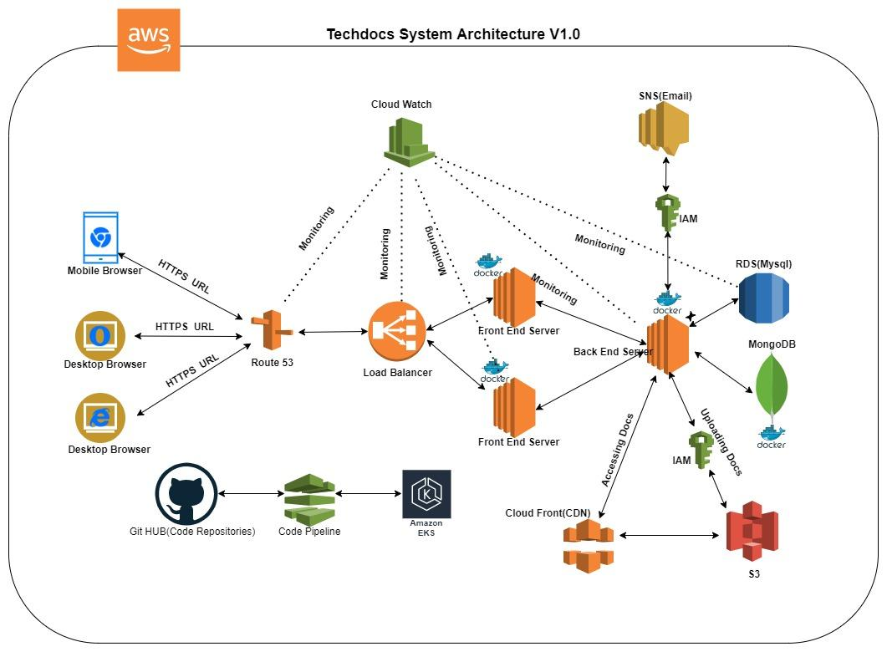

We used maximum AWS services here to deploy it in a better way.

To start with, If people access front end web application through mobile or desktop browser, To access the application in a HTTPS url ( which is a secured application domain url ) we have to map to our application.When they hit that https url in the browser, it will go to route53.

## Services used here :

### **Route53**

Route53 is a DNS mapping service. This will identify what is the corresponding internal IP address and helps to redirect that. This also helps to get an SSL certificate(ssl means accessing url with https).

### **Load Balancer**

Assuming there is a heavy load coming on to the server, instead of a single server handling the complete load we may split the application and deploy the application in two of the servers. Load gets equally divided and load balancer IP will be given to Route53 and the request is forwarded to the front end server. Front end will be communicating with the back end as a restful API web service. Restful service calls will go to the back end and the back end will do the job. It will return the response back to the front end and the front end will iterate the response.

### **S3 (Simple Storage Service)**

Amazon S3 is an object storage service that stores data as objects within buckets. An *object* is a file and any metadata that describes the file. A *bucket* is a container for objects.

To store your data in Amazon S3, you first create a bucket and specify a bucket name and AWS Region. Then, you upload your data to that bucket as objects in Amazon S3. Each object has a *key* (or *key name*), which is the unique identifier for the object within the bucket.

S3 provides features that you can configure to support your specific use case. For example, you can use S3 Versioning to keep multiple versions of an object in the same bucket, which allows you to restore objects that are accidentally deleted or overwritten.

Buckets and the objects in them are private and can be accessed only if you explicitly grant access permissions. You can use bucket policies, AWS Identity and Access Management (IAM) policies, access control lists (ACLs), and S3 Access Points to manage access.

### **IAM ( Identity Access Management)**

AWS Identity and Access Management (IAM) is a web service that helps you securely control access to AWS resources. You use IAM to control who is authenticated (signed in) and authorized (has permissions) to use resources.

When you create an AWS account, you begin with one sign-in identity that has complete access to all AWS services and resources in the account. This identity is called the AWS account *root user* and is accessed by signing in with the email address and password that you used to create the account. We strongly recommend that you do not use the root user for your everyday tasks. Safeguard your root user credentials and use them to perform the tasks that only the root user can perform.

We have to create one user for this s3 storage uploading purpose where that user is having access to the s3 service of that account and that user credentials are used in the code of flask API and they will connect to the service and push the document which is stored in the s3 bucket.

### **Cloudwatch**

Amazon CloudWatch monitors your Amazon Web Services (AWS) resources and the applications you run on AWS in real time. You can use CloudWatch to collect and track metrics, which are variables you can measure for your resources and applications.

The CloudWatch home page automatically displays metrics about every AWS service you use. You can additionally create custom dashboards to display metrics about your custom applications and display custom collections of metrics that you choose.

You can create alarms that watch metrics and send notifications or automatically make changes to the resources you are monitoring when a threshold is breached. For example, you can monitor the CPU usage and disk reads and writes of your Amazon EC2 instances and then use that data to determine whether you should launch additional instances to handle increased load. You can also use this data to stop under-used instances to save money.

With CloudWatch, you gain system-wide visibility into resource utilization, application performance, and operational health.

### **Amazon Simple Notification Service (Amazon SNS)** coordinates and manages the delivery or sending of messages to subscribing endpoints or clients. You use Amazon SNS with CloudWatch to send messages when an alarm threshold has been reached. For more information, see **Setting up Amazon SNS notifications.**

### **CloudFront ( Content Delivery Network )**

Amazon CloudFront is a web service that speeds up distribution of your static and dynamic web content, such as .html, .css, .js, and image files, to your users. CloudFront delivers your content through a worldwide network of data centers called edge locations. When a user requests content that you're serving with CloudFront, the request is routed to the edge location that provides the lowest latency (time delay), so that content is delivered with the best possible performance.

● If the content is already in the edge location with the lowest latency, CloudFront delivers it immediately.

● If the content is not in that edge location, CloudFront retrieves it from an origin that you've defined—such as an Amazon S3 bucket, a

MediaPackage channel, or an HTTP server (for example, a web server) that you have identified as the source for the definitive version of your content.

As an example, suppose that you're serving an image from a traditional web server, not from CloudFront. For example, you might serve an image, sunsetphoto.png, using the URL https://example.com/sunsetphoto.png.

Your users can easily navigate to this URL and see the image. But they probably don't know that their request is routed from one network to another—through the complex collection of interconnected networks that comprise the internet—until the image is found.

CloudFront speeds up the distribution of your content by routing each user request through the AWS backbone network to the edge location that can best serve your content. Typically, this is a CloudFront edge server that provides the fastest delivery to the viewer. Using the AWS network dramatically reduces the number of networks that your users' requests must pass through, which improves performance. Users get lower latency—the time it takes to load the first byte of the file—and higher data transfer rates.

You also get increased reliability and availability because copies of your files (also known as *objects)* are now held (or cached) in multiple edge locations around the world.

### **RDS**

Amazon Relational Database Service (RDS) is a managed SQL database service provided by Amazon Web Services (AWS). Amazon RDS supports an array of database engines to store and organize data. It also helps in relational database management tasks like data migration, backup, recovery and patching.

Amazon RDS facilitates the deployment and maintenance of relational databases in the cloud. Cloud administrators use Amazon RDS to set up, operate, manage, and scale relational instances of cloud databases. Amazon RDS itself is not a database; It is a service used to manage relational databases.

### **How does Amazon RDS work?**

Databases store large amounts of data that applications can draw upon to help them perform various tasks. A relational database uses tables to store data and is called relational because it organizes data points with defined relationships.

Administrators control Amazon RDS with the AWS Management Console, Amazon RDS API calls, or the AWS command-line interface. They use these interfaces to deploy database instances to which users can apply specific settings.

Amazon provides several instance types with different resources, such as CPU, memory, storage options, and networking capability. Each type comes in a variety of sizes to suit the needs of different workloads.

RDS users can use AWS Identity and Access Management to define and set permissions to access RDS databases.

### **Code Pipeline**

AWS CodePipeline is a fully managed continuous delivery service that helps you automate your release pipelines for fast and reliable application and infrastructure updates.

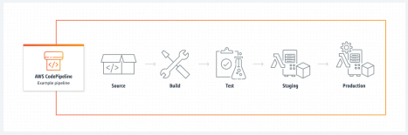

9

## What Is A Docker?

## 

Docker is a software platform that allows you to build, test, and deploy applications quickly. Docker packages software into standardized units called containers that have everything the software needs to run including libraries, system tools, code, and runtime. Using Docker, you can quickly deploy and scale applications into any environment and know your code will run.

Running Docker on AWS provides developers and admins a highly reliable, low-cost way to build, ship, and run distributed applications at any scale.

Docker collaborates with AWS to help developers speed delivery of modern apps to the cloud. This collaboration helps developers use Docker Compose and Docker Desktop to leverage the same local workflow they use today to seamlessly deploy apps on Amazon ECS and AWS Fargate.

## Why Use Docker?

Using Docker lets you ship code faster, standardize application operations, seamlessly move code, and save money by improving resource utilization. With Docker, you get a single object that can reliably run anywhere. Docker's simple and straightforward syntax gives you full control. Wide adoption means there's a robust ecosystem of tools and off-the-shelf applications that are ready to use with Docker.

## Deploying Docker Containers with AWS EC2 Instance

Let’s Explore how to deploy your Docker container/Image in AWS EC2 Instance.

### **What Is EC2 Instance?**

* An EC2 instance is nothing but a virtual server in Amazon Web services terminology.
* It stands for Elastic Compute Cloud.
* It is a web service where an AWS subscriber can request and provision a compute server in AWS cloud.

### **Steps To Deploy docker images in EC2 Instance:**

#### Step 1: Launching EC2 Instance

In AWS Console search for EC2 and click on that service, you will redirect to the AWS EC2 page as follows and then Click on **Launch Instance.**

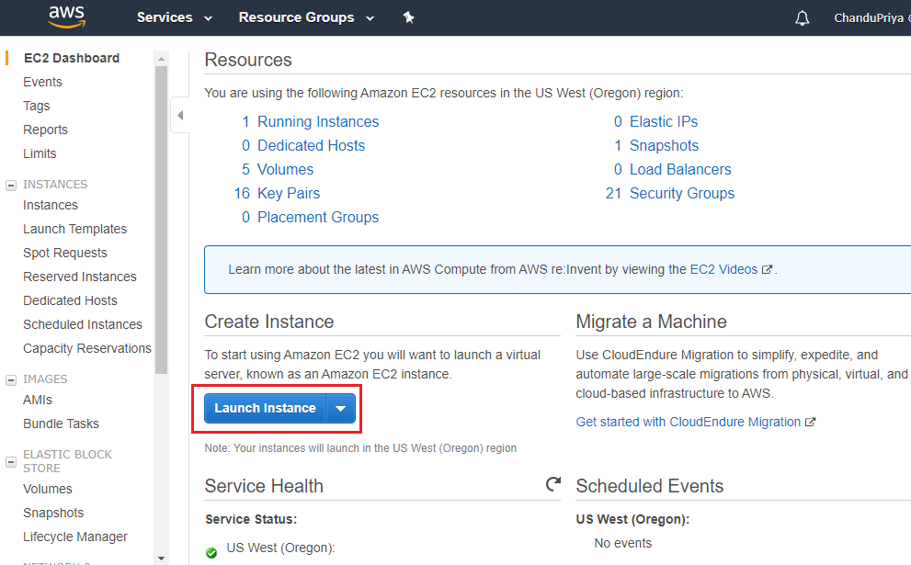

To run EC2 successfully, select an Amazon Machine Image (AMI). AMI contains all the software configurations (operating system, application server, and applications) required to launch your instance. In this case, we will pick Amazon Linux AMI.

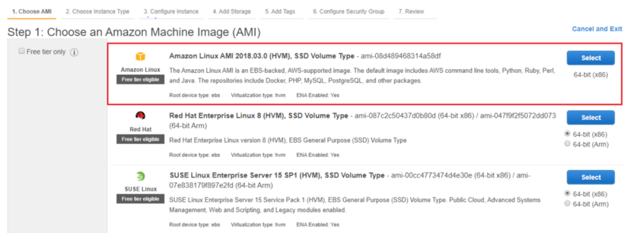

Now, select the Instance Type that determines the type of CPU, storage, network capacity, and memory needed during the installation. Choose t2.micro, and hit the next button as shown below:

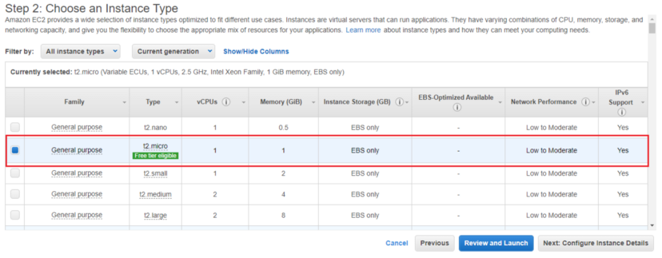

Click the next button until you reach to the Configure Security Group page to retain the default settings. A security group is a set of firewall rules that control the traffic for your instance. On this page, you can add rules to allow specific traffic to reach your instance.

For example, if you want to set up a web server and allow Internet traffic to reach your instance, add rules that allow unrestricted access to the HTTP and HTTPS ports.

Enter the Security Group name and then hit the **Review and Launch** button.

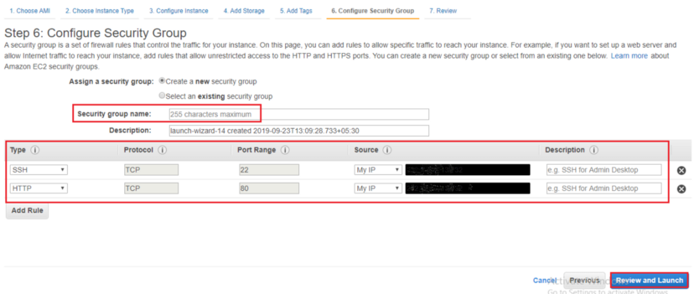

After hitting the Launch button you will see a pop-up page that requires you to select a Key Pair. This contains both a public and private key folder that is used to connect to your EC2 Instance securely via SSH. Click on the “create a new key pair” button and give name to the key pair. Go ahead and download your key pair.

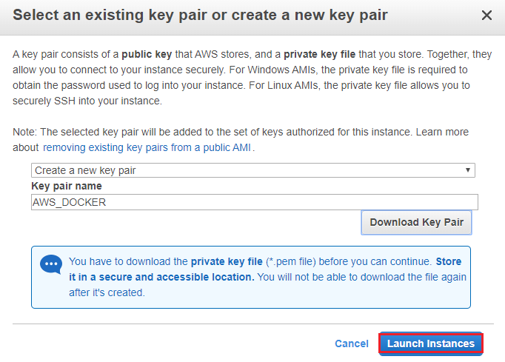

Save your key file to a safe place on your system and then click on Launch Instances, it will direct you to the launching page. Hit the “View Instances” button to access the EC2 Instances page.

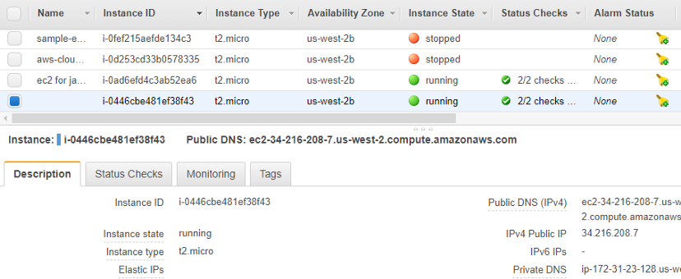

you can see the details of EC2 Instances present like public address and launch time. Copy the IP address, because you will use it on SSH to install Docker.

#### Step2 : How To Install Docker On EC2 Instance

To install Docker on the EC2 Instance. Go to the location path where your Key Pair is saved, open terminal and type the following command:

**ssh -i keypair.pem ec2-user@<EC2-INSTANCE-PUBLIC-IP-ADDRESS>**

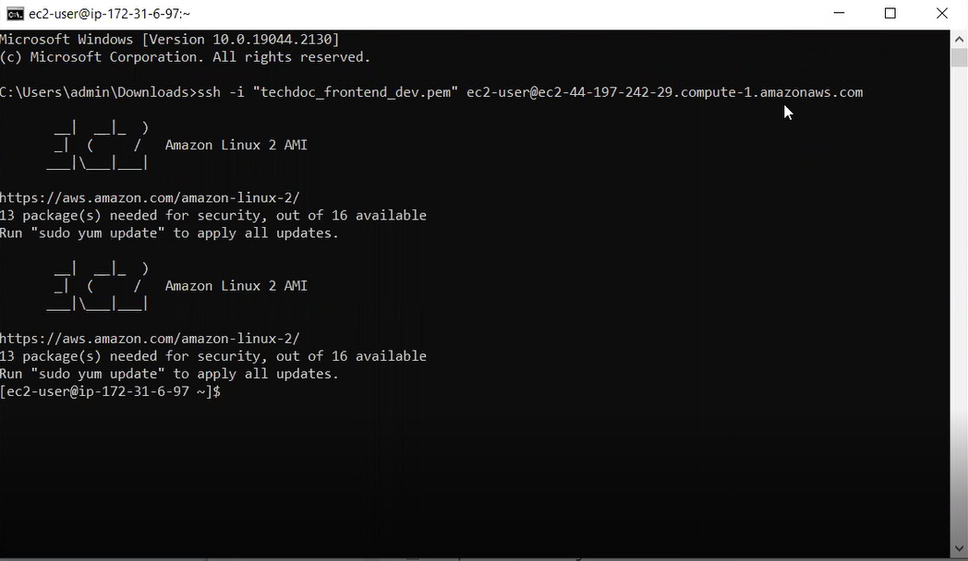

You have connected to your EC2 instance, Now you can install docker by using the below command:

**sudo yum install -y docker**

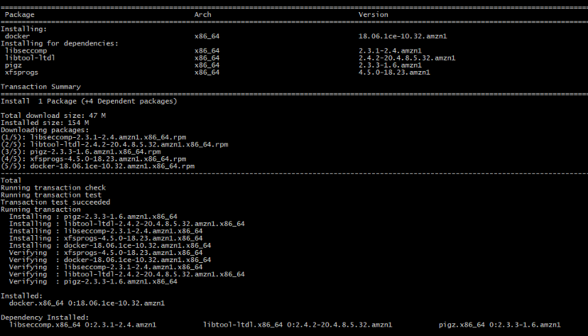

Use this command to start the docker:

**sudo service docker start**

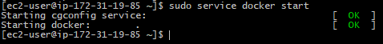

**docker info**

If you done everything right, the above command will shows info about Docker installation without showing any errors.

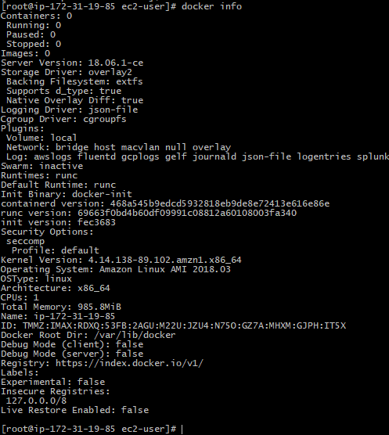

If docker is not enabled, Then you can give the following command:

**sudo systemctl enable docker.service**

To start Docker use this:

**sudo systemctl start docker.service**

To check the status of docker use this :

**sudo systemctl status docker.service**

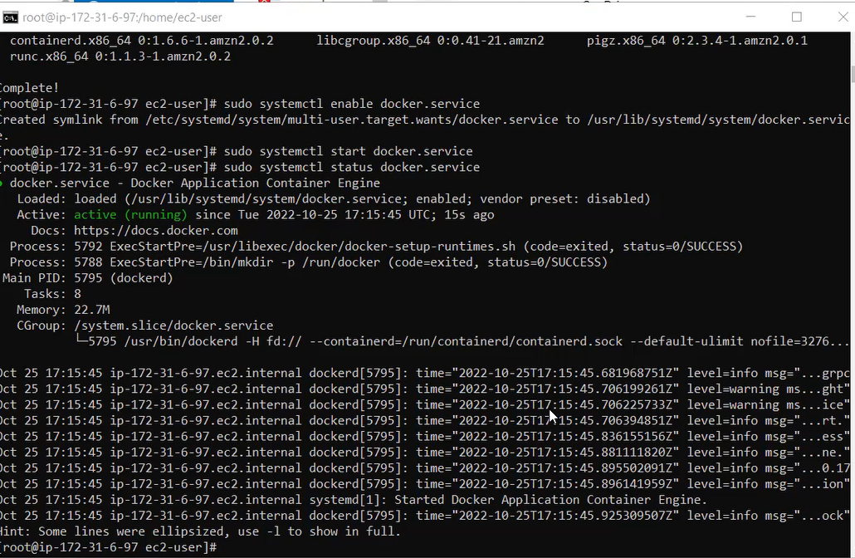

Now the docker being active, the next step we have done here is we installed git inorder to bring the code available in the git repository and from the docker file in the code we start building the image from it.

To install git , use the following:

**yum install git**

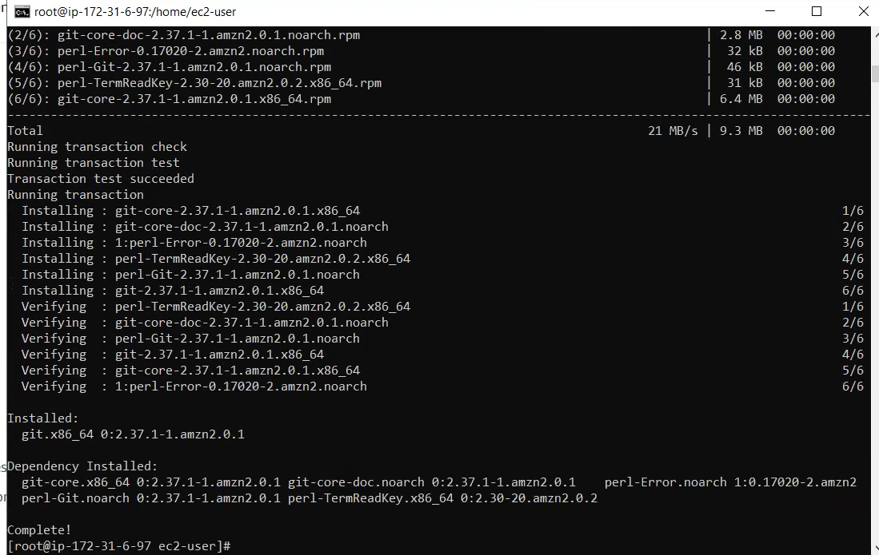

Using git clone command you have to clone the repository where your code is stored. Go to the location where your docker file is there and then build image from it.

You can build image with the following command:

**docker build -t <imagename> .**

After successfully building the image, you have to run the image by giving the command as:

**docker run <imagename>**

Since we ran our container in the background, how do we know if our container is running or what other containers are running on our machine? Well, to see a list of containers running on our machine, run docker ps. This is similar to how the ps command is used to see a list of processes on a Linux machine.

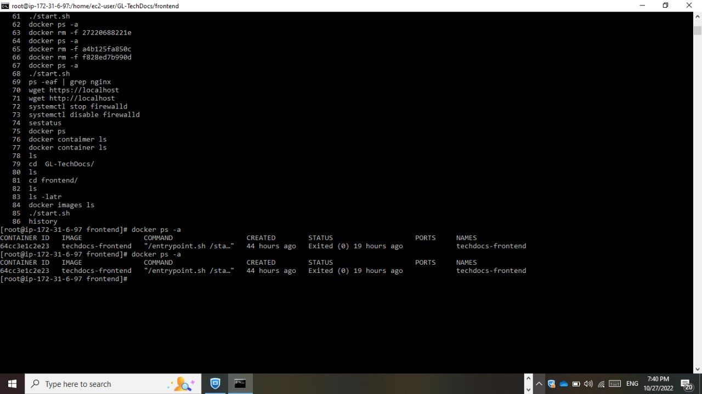

You can observe some monitoring of services which we did through AWS CloudWatch.Below is the pic of some performance metrics of servers.

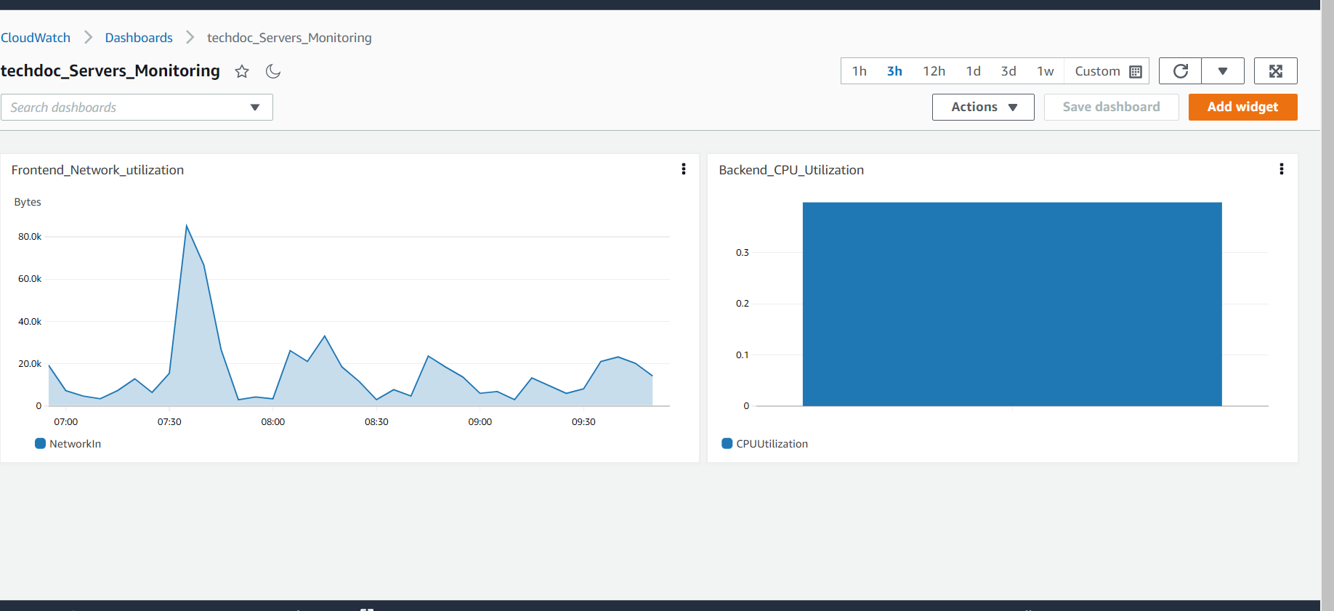

# **Appendix**

## Appendix A

### **API documentation**

##### **/api/register**

**POST** Create a new user

**Description:** This API allows an individual to register as a new user. It will accept an email id to complete the registration. The user name will be the email id itself and the user has to set their password.

**Body Raw (json)**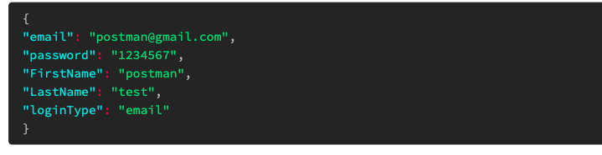

**Response raw(json) 200** 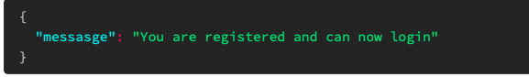

##### **/api/signin**

**POST** User sign in

**Description:** This API authenticates the user. After a successful authentication, a non-expiring JWT token is generated and the API returns it along with first name, last name and isAdmin.

**Body form-data 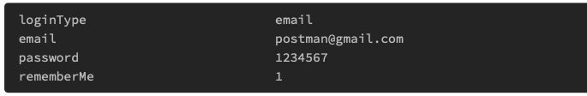Response raw(json) 200** 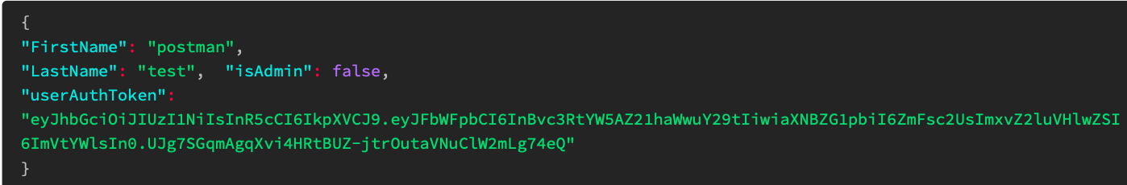

##### **/api/getProfile**

**POST** Get user profile details

**Description:** After validating the auth token in the header, the API returns the user details as shown in the response.

**Request headers**

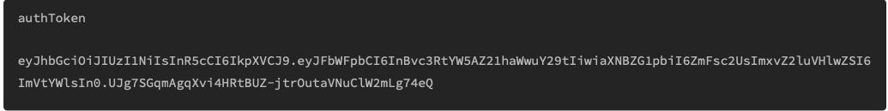

**Response raw(json) 200** 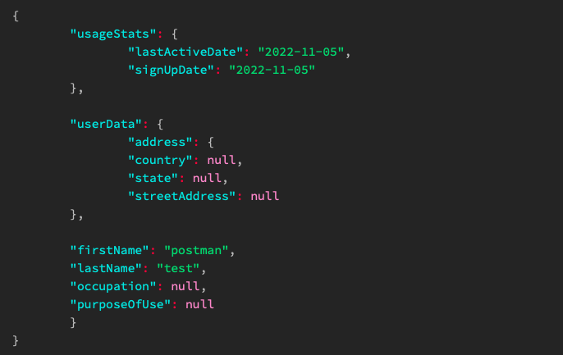

##### **/api/updateProfile**

**POST** Get user profile details

**Description:** After validating the auth token, the api allows the user to update their profile details such as first name, last name, street address, state, country, occupation, purpose of use.

**Request headers** 

**Body raw(json)**  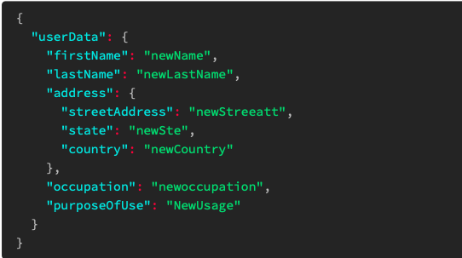

**Response raw(json) 200** 

##### **/api/changePassword**

**POST** Change current password

**Description:** This API allows users to change their password by validating their current password and accepting the new password.

**Request headers** 

**Body form-data** 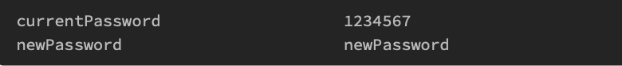

**Response raw(json) 200** 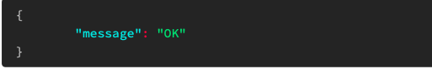

##### **/api/forgot-password**

**POST** Reset password

**Description:** This API sends a password reset link to the provided email id if the email id is found in the database.

**Body form-data** 

**Response raw(json) 200** 

##### 

##### **/api/signout**

**POST** User signout

**Description:** The API updates the last active date in the user profile, and sends out a JWT token as a success response.

**Request headers**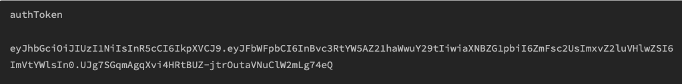

**Response raw(json) 200** 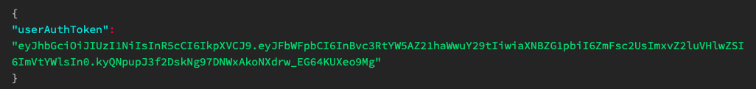

##### 

##### **/api/deleteAccount**

**POST** Delete user profile

**Description:** This API allows users to delete their profile. It requests the users to enter their current password for confirmation.

**Request headers 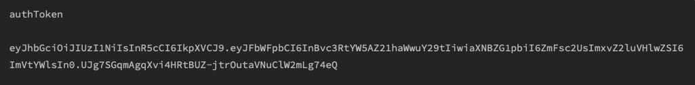Body form-data** 

**Response raw(json) 200** 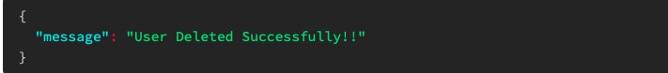

**/api/filecreate**

**POST** Create a file

**Description:** This API allows users to create a new file. When the file is created the user is assigned appropriate permissions as the file owner. This file content can either be empty or already have data in it.

**Request headers 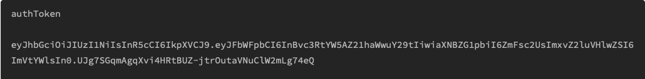Body raw(json) 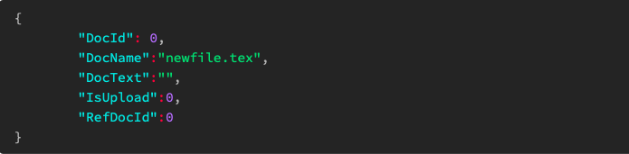Response raw(json) 200** 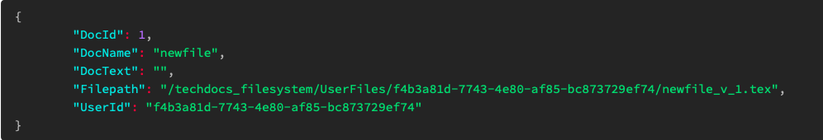

##### **/api/filemodify**

**POST** Update the contents of file

**Description:** This API saves the changes made in a file (if the user has write permission) as a new version of the file.

**Request headers 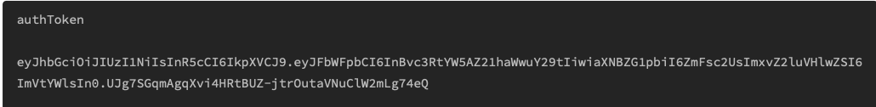Body raw(json) 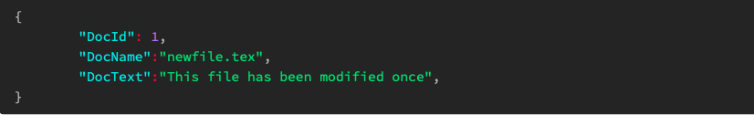Response raw(json) 200** 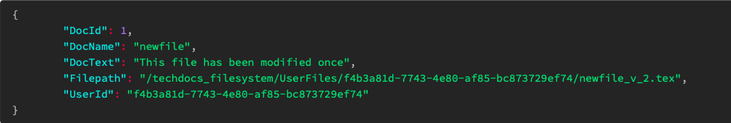

##### 

##### **/api/fileview**

**POST** Update the contents of file

**Description:** This API returns the contents of the file of the provided document id if the user has read permission.

**Request headers 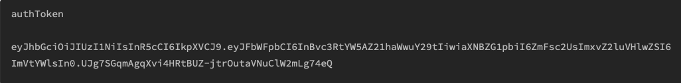Body raw(json)**  

**Response raw(json) 200** 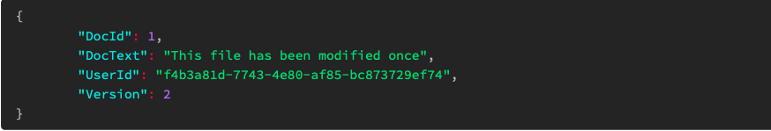

##### 

##### **/api/filerename**

**POST** Rename file

**Description:** This API allows the user to rename the existing files if they have the write permission.

**Request headers** **Body raw(json)** 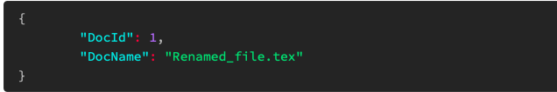

**Response raw(json) 200** 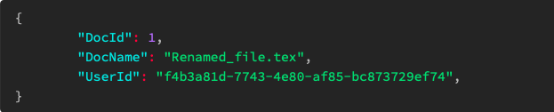

##### **/api/getsharedlist**

**GET** Shared File list

**Description:** This API allows the user to get a list of files shared were shared with them.

**Request headers**

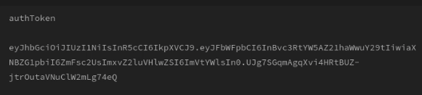

**Response raw(json) 200**

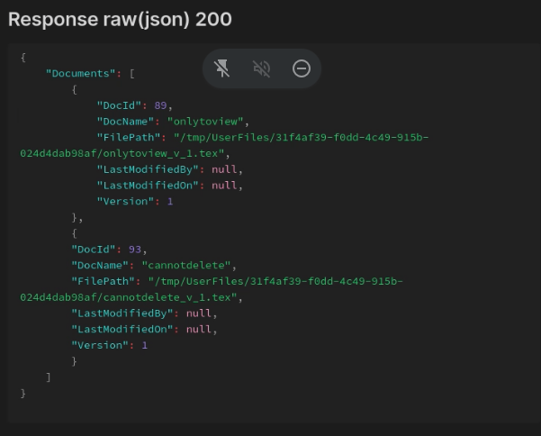

**/api/filegetlist**

**GET** List of files owned

**Description** This API returns the list of latest versions of the files owned by the user with other details of the file as shown in the response

**Request headers** **Response raw(json) 200** 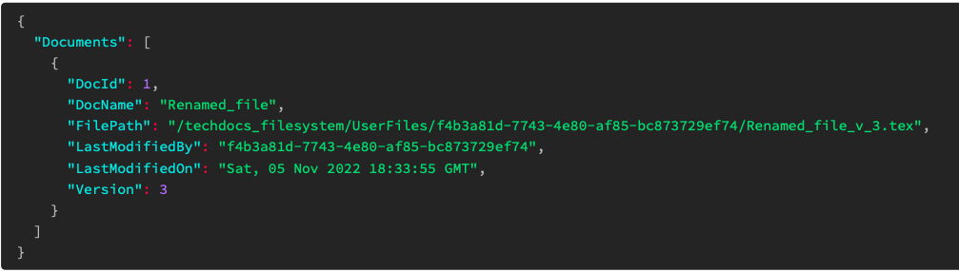

**/api/filetrash**

POST Trash a file

**Description:** This API allows a user to trash all versions of a file if the user has the delete permission. The file can be retrieved by the retrieve files api.

**Request headers** 

**Body raw(json)**

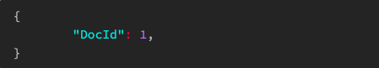

**Response raw(json) 200**

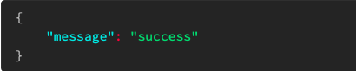

##### **/api/fileretrive**

**POST** Retrieve a file

**Description:** This API allows a user to retrieve all versions of a file from trash.

**Request headers** 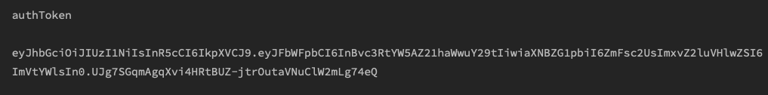

**Body raw(json)**

 **Response raw(json) 200**

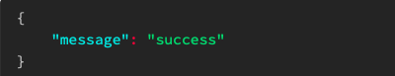

##### **/api/filedelete**

**POST** Delete a file

**Description:** This API allows a user to permanently delete all versions of a file if the user has delete permissions.

**Request headers** **Body raw(json)**



**Response raw(json) 200**



##### **/api/getTrashList**

**GET** List of trash files

**Description:** This API returns the list of all the files a user has trashed

**Request headers** 

**Response raw(json) 200**

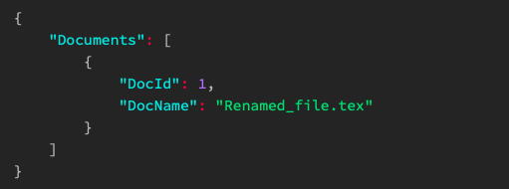

##### **/api/set_permissions**

**POST** Give permission to a file

**Description:** This API allows a user to set a permission such as read, write,share and delete of a file to other user

**Request headers** **Body raw(json)** 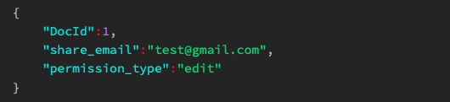

**Response raw(json) 200** 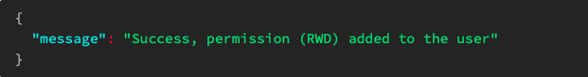

##### **/api/get-permissions**

**GET** Get user permission of a file

**Description:** This API returns the file permissions of a user.

**Request headers** **Body raw(json)**  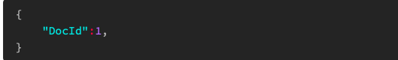

**Response raw(json) 200**  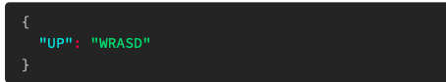

##### **/api/historyGet**

**POST** User action history

**Description:** This API returns all the actions performed by a user such as edit, create, rename and delete along with the timestamp

**Request headers** 

**Response raw(json) 200**

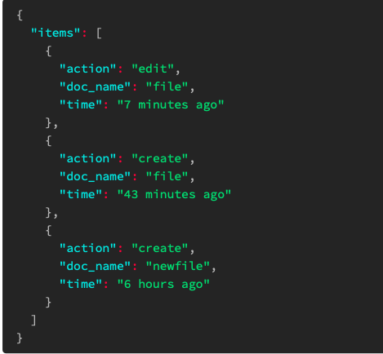

## 

## Appendix B

## Database description

### **Entity Relationship Diagram**

##### **For User database**

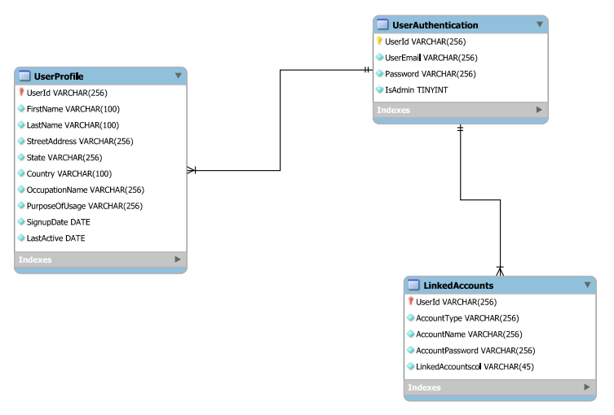**Tables:**

**User table:**

|  |  |  |
| --- | --- | --- |
| **Columns** | **Data Type** | **Properties** |
| UserId | varchar(256) | Primary Key, Unique |
| UserName | varchar(256) |  |
| Password | varchar(256) | Hashed password |
| IsAdmin | boolean | Default : False |
| LoginType | varchar(256) | Default : False |

**UserProfile table:**

|  |  |  |
| --- | --- | --- |
| **Columns** | **Data Type** | **Properties** |
| UserId | varchar(256) | Primary Key, Foreign Key, Unique |
| UserName | varchar(256) | Foreign Key |
| FirstName | varchar(100) |  |
| LastName | varchar(100) |  |
| StreetAddress | varchar(256) |  |
| State | varchar(256) |  |
| Country | varchar(100) |  |
| Occupation | varchar(256) |  |
| PurposeOfUsage | varchar(256) |  |
| SignUpDate | Date |  |
| LastActiveDate | Date |  |

**LinkedAccount table:**

|  |  |  |
| --- | --- | --- |
| **Columns** | **Data Type** | **Properties** |
| UserId | varchar(256) | Primary Key, Foreign Key, Unique |
| Account Type | varchar(256) |  |
| Account Name | varchar(256) |  |
| Account Password | varchar(256) |  |

##### **For Document Database**

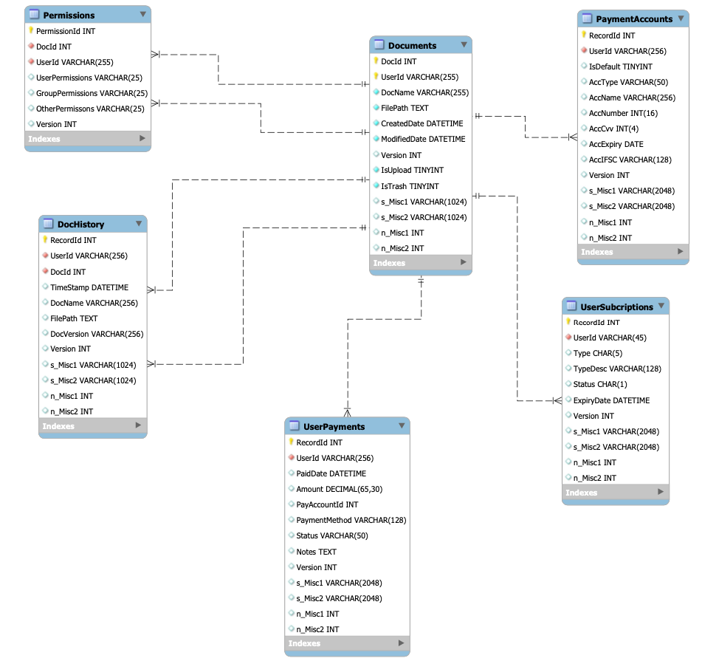

**Tables:**

**Documents table:**

|  |  |  |
| --- | --- | --- |
| **Columns** | **Data Type** | **Properties** |
| DocId | int *(AUTO_INCREMENT)* | Primary key |
| UserId | varchar(256) | Foreign key |
| DocName | varchar(256) |  |
| FilePath | text | Unique key constraint |
| CreatedDate | datetime | Index by UserId, DocId |
| ModifiedDate | datetime | Index by UserId, CreatedDate |
| ModifiedBy | varchar(256) | Index by UserId, ModifiedDate |
| Version | int |  |
| IsTrash | char(1) |  |
| s_Misc1 | varchar(1024) | Miscellaneous fields for additional use |
| s_Misc2 | varchar(1024) | Miscellaneous fields for additional use |
| n_Misc1 | int | Miscellaneous fields for additional use |
| n_Misc2 | int | Miscellaneous fields for additional use |

**Permissions table:**

|  |  |  |
| --- | --- | --- |
| **Columns** | **Data Type** | **Properties** |
| PermissionId | int *(AUTO_INCREMENT)* | Primary key |
| DocId | int | Foreign key 1 |
| UserId | varchar(256) | Foreign key 2 |
| UserPermissions | varchar(25)  *(R-Read/W-Write/S-Share/A-Analytics/D-Delete)* | Index by UserId, DocId |
| GroupPermissions | varchar(25)  *(R-Read/W-Write/S-Share/A-Analytics/D-Delete)* |  |
| OtherPermissions | varchar(25)  *(R-Read/W-Write/S-Share/A-Analytics/D-Delete)* |  |
| Version | int |  |

## 

**DocHistory table:**

|  |  |  |
| --- | --- | --- |
| **Columns** | **Data Type** | **Properties** |
| RecordId | int *(AUTO_INCREMENT)* | Primary key |
| UserId | varchar(256) | Foreign key 1 |
| DocId | int | Foreign key 2 |
| TimeStamp | datetime | Index by UserId, DocId |
| DocName | varchar(256) |  |
| FilePath | text |  |
| DocVersion | varchar(256) |  |
| Version | int |  |
| s_Misc1 | varchar(1024) | Miscellaneous fields for additional use |
| s_Misc2 | varchar(1024) | Miscellaneous fields for additional use |
| n_Misc1 | int | Miscellaneous fields for additional use |
| n_Misc2 | int | Miscellaneous fields for additional use |

**UserPayments table:**

**Used for user payment history**

|  |  |  |
| --- | --- | --- |
| **Columns** | **Data Type** | **Properties** |
| RecordId | int *(AUTO_INCREMENT)* | Primary key |
| UserId | varchar(256) | Foreign key 1 |
| PaidDate | datetime | Foreign key 2 |
| Amount | decimal(65,30) | Index by UserId and PaidDate |
| PayAccountId | int |  |
| PaymentMethod | varchar(128)  *(card; netbank; UPi)* |  |
| Status | varchar(50)  *(Success; Fail)* |  |
| Notes | text |  |
| Version | int |  |
| s_Misc1 | varchar(2048) | Miscellaneous fields for additional use |
| s_Misc2 | varchar(2048) | Miscellaneous fields for additional use |
| n_Misc1 | int | Miscellaneous fields for additional use |
| n_Misc2 | int | Miscellaneous fields for additional use |

**PaymentAccounts Table:**

|  |  |  |
| --- | --- | --- |
| **Columns** | **Data Type** | **Properties** |
| RecordId | int *(AUTO_INCREMENT)* | Primary key |
| UserId | varchar(256) | Foreign key 1 |
| IsDefault | bool  (*0, 1)* | Index by UserId |
| AccType | varchar(50)  *(creditcard; debitcard; personal)* |  |
| AccName | varchar(256) |  |
| AccNumber | int(16) |  |
| AccCvv | int(4) |  |
| AccExpiry | date |  |
| AccIFSC | varchar(128) |  |
| Version | int |  |
| s_Misc1 | varchar(2048) | Miscellaneous fields for additional use |
| s_Misc2 | varchar(2048) | Miscellaneous fields for additional use |
| n_Misc1 | int | Miscellaneous fields for additional use |
| n_Misc2 | int | Miscellaneous fields for additional use |

**UserSubscriptions table:**

|  |  |  |
| --- | --- | --- |
| **Columns** | **Data Type** | **Properties** |
| RecordId | int *(AUTO_INCREMENT)* | Primary key |
| UserId | varchar(256) | Foreign key 1 |
| Type | char(5)  (F - Free; PC - Paid Corporate) | Default Values  Type: Free  TypeDesc: Personal  Status: A |
| TypeDesc | varchar(128)  (*Personal; Corporate*) |  |
| Status | Char(1)  *(Active; Inactive)* |  |
| ExpiryDate | datetime |  |
| Version | int |  |
| s_Misc1 | varchar(2048) | Miscellaneous fields for additional use |
| s_Misc2 | varchar(2048) | Miscellaneous fields for additional use |
| n_Misc1 | int | Miscellaneous fields for additional use |
| n_Misc2 | int | Miscellaneous fields for additional use |